
www.brailleliteracycanada.ca
info@blc-lbc.ca

Accessible Braille Signage – Quick Reference Guide
Refer to Braille Literacy Canada’s 2024 Accessible Signage Guidelines (ASG) for detailed explanations of the following recommendations.

- Left justify braille and print text.
- Use initial letter capitalization for both print and braille.
- Use contrasting colour for braille dots, embossed lettering and pictograms, such as white dots or text on dark blue background (avoid use of clear braille dots).
- Braille characters must follow exact size and spacing specifications (refer to ASG). Braille cannot be enlarged, as it is read with the fingertips.
- Empty spaces between braille cells must be preserved to mitigate the braille becoming unreadable. Do not add any extra spaces between words or characters.
- The standard for English braille in Canada is Unified English Braille (UEB). It is essential to ensure that signs are produced in UEB. For French text, use Code braille français (CBFU).
- Follow braille rules with letter-number or number-letter sequences (refer to ASG).
- For signs of 10 words or less use uncontracted braille (grade one), which provides character-to-character correlation between print and braille.
- Braille must be embossed (raised). Use raised pictograms and raised print, as some people new to vision loss or who may have a print disability may not be able to read braille, but can feel the shape of the letters to confirm the information.
- Use a print font that is NOT condensed (refer to ASG for recommended fonts). Condensed fonts make it more difficult for people who have low vision to discern the letters.
- Use plain backgrounds. Avoid placing braille or text over logos, patterns, or multi-coloured images.
- Use glare-free matte finishes. Avoid reflective, glossy, or metallic backgrounds.
- The braille should be in the same language(s) as the print.
- Keep the text of each format as one block. Braille block follows print block.
- When signage includes both English and French text, both English and French braille are included. Keep the text of each language as one block of text. A side-by-side layout of English and French raised text and braille is suggested.
- Make sure that all the visual information on the sign is represented in braille, especially noting the information conveyed on pictograms that might not be spelled out in print. (see example)*.
- Consistent formatting across all signage in building.
- Consistent placement and specified height for signage throughout the building.
- Maintain the permanency of your signage by completing scheduled building signage audits.
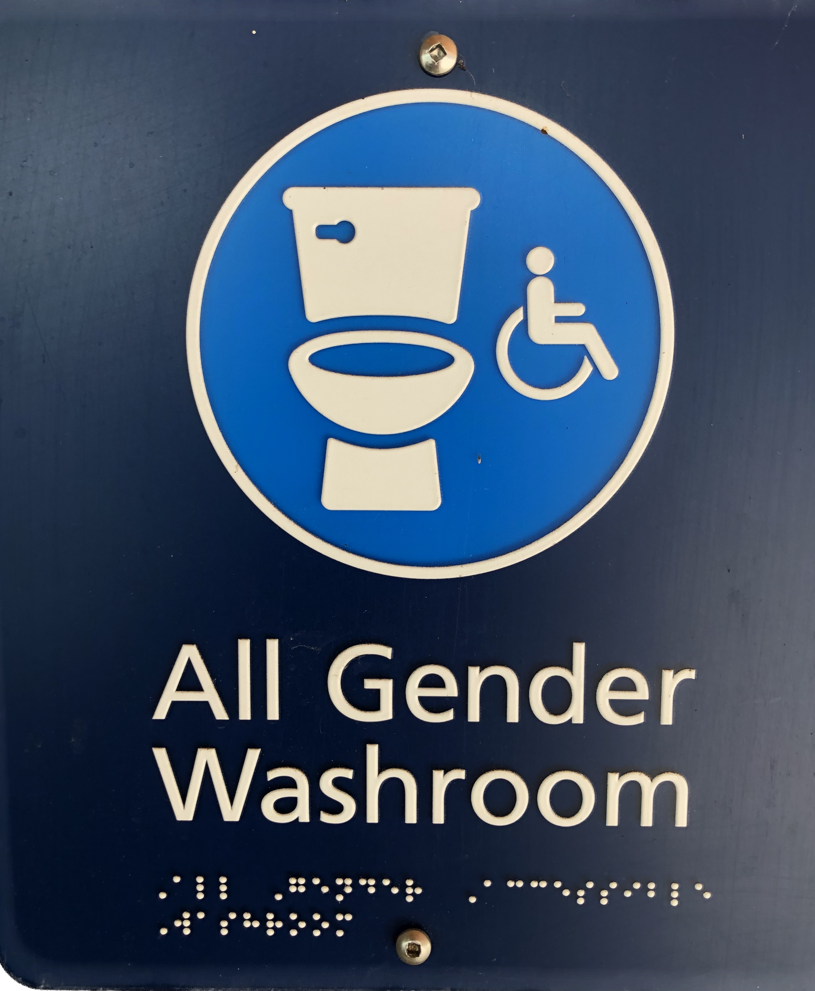
* The same information provided in print and a pictogram should be provided in braille. For example, a sign indicates in print ‘All Gender Washroom’ and is accompanied by a pictogram of a toilet and a wheelchair. This provides visual information that the washroom is an “All Gender Accessible Washroom.” For best practices, the braille should give that same information.

Print: All Gender Washroom
Braille: ⠠⠁⠇⠇⠀⠠⠛⠑⠝⠙⠑⠗⠀⠠⠁⠉⠉⠑⠎⠎⠊⠃⠇⠑ ⠀⠠⠺⠁⠎⠓⠗⠕⠕⠍
All Gender Accessible Washroom

