Accessible
Signage Guidelines
2024

Braille Literacy Canada, the Canadian Braille Authority
Littératie Braille Canada, l’Autorité canadienne du braille

Developed by the Formats Committee of Braille Literacy Canada

MISSION STATEMENT
Braille Literacy Canada / Littératie braille Canada was originally founded in 1990 as the Canadian Braille Authority / l’Autorité canadienne du braille. Braille Literacy Canada (BLC-LBC) promotes braille as the primary medium of literacy for those who are blind, DeafBlind or visually impaired. All Canadians who require braille in order to access information effectively have the right to braille literacy.

TABLE OF CONTENTS
MISSION STATEMENT ii
INTRODUCTION 1
WHERE ARE ACCESSIBLE SIGNS NEEDED? 3
GUIDELINES FOR ACCESSIBLE SIGNAGE 4
1. General 4
1.1 Placement 5
1.2 Contrast 9
1.3 Layout 9
1.4 Durability and Maintenance 10
2. Braille Signage 10
2.1 Technical Specifications: Braille Dot Profile 10
2.2 Technical Specifications: Braille Configuration on Signage 12
3. Clear, Raised Print Signage 13
3.1 Readability by Sight 13
3.2 Readability by Touch 14
4. Pictograms 14
5. Electronic Digital Signage 15
6. French 16
Appendix 1: FREQUENTLY ASKED QUESTIONS 17
Appendix 2: NUMBERS 19
Appendix 3: FRENCH 21
Appendix 4: EXAMPLE OF SIGNAGE INVENTORY AUDIT 22
Appendix 5: ACCESSIBLE SIGNAGE CHECK LIST 25
REFERENCES 26
Canadian Provincial Resources 27

INTRODUCTION
These guidelines recommend best practice for the design of braille signage which is to be read by touch by braille readers. Braille signage is an essential tool for accessibility and helps ensure that people who are blind, DeafBlind or with low vision have equal access to information posted in public spaces.

The Canadian Human Rights Act requires that public spaces be accessible and free of barriers. The Accessible Canada Act introduces strengthened requirements to remove accessibility barriers at the federal level, including those related to the accessibility of public places.

The United Nations Convention on the Rights of Persons with Disabilities (UNCRPD) was ratified by the Canadian government in 2010. The Convention mentions braille and tactile signage specifically. Article 9(2)d requires that public spaces employ signage in braille and forms that are easy to read and understand.
Good design means everyone benefits. People who use your building or facility may be blind, low vision or DeafBlind. This means the only way they can access the vital information conveyed by building signage is through touch or through signage that incorporates high contrast and clear print. One should also consider Braille. See below for a list of benefits.

Accessible Design Principles:
- Universal Benefit: Good design practices ensure accessibility for all users, including those with visual impairments.
For Individuals with Vision Impairments:
- Tactile Signage: People who are blind or have low vision may rely on touch to read signage.
- High-Contrast Visuals: Clear print and high contrast are crucial for those who are DeafBlind or have low vision.

Understanding Braille:
- Braille Signage: Braille uses raised dots to represent letters and provides fast information access for braille readers, crucial for safety instructions.
- Raised Print: Many individuals who are newly blind or older do not read braille but can read raised print by touch.
Inclusive Signage Recommendations:
- Dual Format Signage: Braille Literacy Canada recommends signs to include both braille and high-contrast raised print.
- Universal Design: This approach adheres to universal design principles, enhancing inclusivity by offering multiple modes of access.

Application of the following guidelines will help to ensure that the signage in your building or facility is readable to all who use it, including blind, DeafBlind and low vision people.

Notes: Throughout these guidelines, BLC uses the term “low vision”, however some prefer the term partially sighted.
The illustrations are not drawn to scale. They are examples only and are not intended to represent all possible renderings. Please always refer to the text for exact measurements and specifications.

WHERE ARE ACCESSIBLE SIGNS NEEDED?
Accessible signs should be provided for any features of a building that would normally be given a print sign. Signs have three functions:
- Informative – to communicate information;
- Directional – to give directions to a facility or service;
- Locational – to identify a location.

Braille and high-contrast tactile print signage must be provided in the following places. These are examples only and do not represent an exhaustive list.
- Washrooms and Showers – both general and specifically accessible facilities
- Elevators – controls and floor indicators
- Numbers on stair landing handrails to allow identification of floors
- Office and hotel room name/number plates
- Emergency doors and exits
- Muster stations, areas of refuge
- Emergency evacuation instructions
- Cautionary signage
- Floor and building directories
- Door controls on public transportation vehicles – emergency and standard
- Free telephones, including direct taxi lines, in shopping malls
- Bus stop and train platform numbers
- Signage in assembly areas and gathering places (arenas, stadiums, auditoriums, places of worship)
- Operating instructions e.g. for vending machines

Where detailed information is provided through signage, for example emergency evacuation instructions or building directories, consider providing this information separately in alternative formats such as braille with tactile diagrams, large print, accessible electronic text and audio. This allows building users to read and refer to the information when they are not standing directly next to the sign.

GUIDELINES FOR ACCESSIBLE SIGNAGE

1. General

- Signs should be accessible to all users of the building or facility, including new braille learners, DeafBlind and low vision people, and those with additional learning difficulties.
- People who are blind, DeafBlind or who have low vision may not know that your building contains accessible signage or tactile maps. It is helpful to include this accessibility information on your website, including how and where signage is located.
- Signage should be permanently mounted on a solid surface.
- The most accessible sign is one which contains braille, high contrast raised print and high contrast raised pictograms where appropriate (for example, male and female washrooms). Always accompany any pictogram with print and braille text. Some readers will not know what the pictogram means without accompanying text.
- Where possible, braille, print and pictograms should be included on the same sign. Having multiple formats on one sign helps some readers clarify or confirm the meaning and strengthens the sign's message.
- The braille should convey the same information as the print.
- The braille should be in the same language(s) as the print.
- When signage includes both English and French text, both English and French braille are included. Keep the text of each language as one block of text. A side-by-side layout of English and French raised text and braille is suggested.
- Keep the text of each format as one block. Braille block follows print block.
- Do not convey information solely through colour or images. Provide information in raised print and braille as well.
- Make signs clear and unambiguous. Keep text short and simple.

1.1 Placement
- Place signs at a consistent height and location around a building or facility. For example, when placing signs to identify specific door numbers, ensure that those signs are always located at the same place (example: to the right of the door). Do not mount signs above the door.
- Place tactile signage where it can be reached easily without obstruction. Avoid placement of objects like planters or chairs beneath the sign.
- Place signs logically and as close as possible to the object they are indicating. (e.g. place "push" near the door opening for easy location).
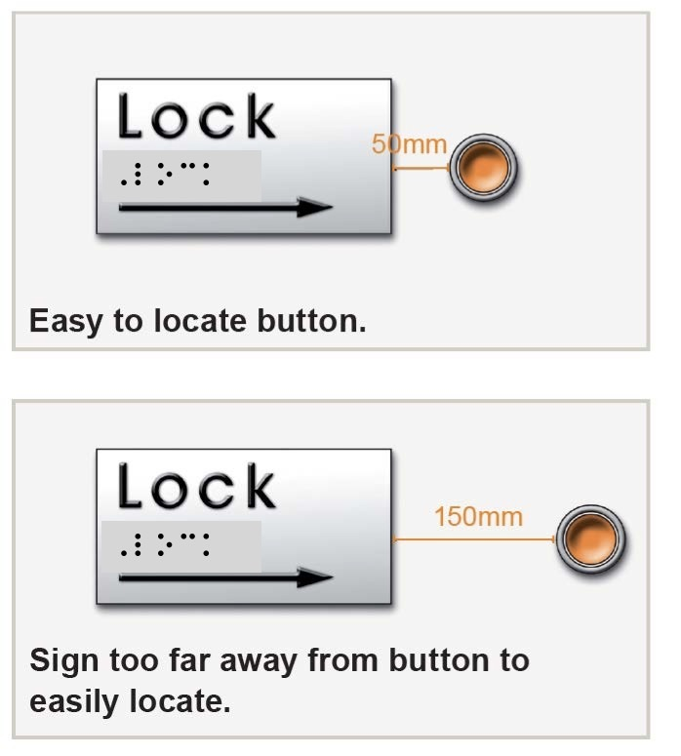
Note: The illustrations are not drawn to scale.
- Place signs at the entry point to corridors.
- In general, where a single sign contains both print, raised print and braille, place signs at a height of 1400-1600mm from floor level to the bottom of the sign. This is based on the optimum viewing height for people standing up and in wheelchairs.
- If braille is placed on a separate sign, this can be lowered to 1350mm from the finished floor to the bottom of the sign plate. Always place separate braille sign plates in a consistent location relative to the print sign.
- For playgrounds, elementary schools, or other facilities where the main population is likely to be children, place the signs between 900-1200mm from floor level to the bottom of the sign plate. But remember that signage also needs to be accessible for adults employed or visiting the facility.
- Avoid suspended signs – they are very difficult to locate and too high to be read by a low vision person.
- Avoid protruding signs or sandwich boards – they are a safety hazard.
- Building directory board placement, locate to the left of the entrance.
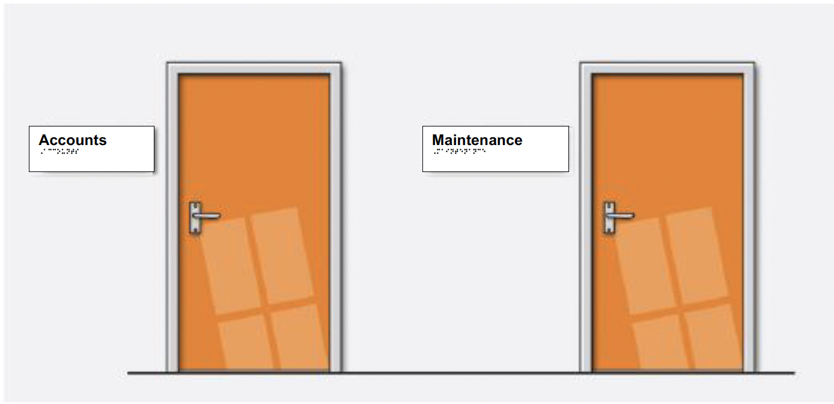
- If doors are generally left open (e.g. office doors), place the sign on the wall or glass, either latch-side or hinge-side, as near to the door as possible. Choose whichever side would be more logical and usable and be consistent throughout the building.
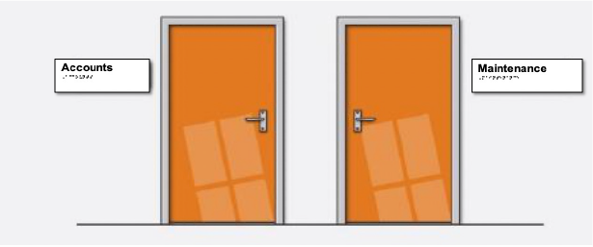
- Place signs at a consistent height and location around a building or facility. In the previous illustration the signs are to the left of each door.
- In this illustration, both signs are on the hinge-side
of each door.

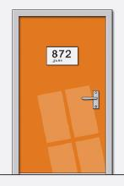
- If doors are generally left closed (e.g. hotel room or washroom doors), place the sign on the door itself. Braille should be placed directly underneath pictograms or print numbers if they exist. Always include braille and print text as well as the pictogram. A pictogram alone is not enough.

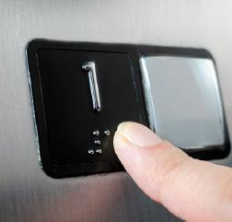
- For elevator controls, place braille to the immediate left of the buttons.
- Place tactile elevator floor indicators on the leading edge of the entrance door or landing frame, at a height of 1350mm from the ground to the bottom dot of braille.
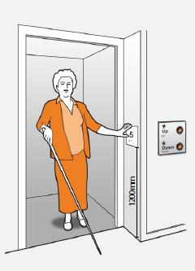
1350mm

- Placement on handrails: Only place braille on handrails if the floor surface is flat to allow for safe standing while reading. This means handrails on stairs should have extensions where braille and tactile print can be placed. It is recommended that the handrail extensions should be at least 300mm in length on both ends of the staircase.
- Be consistent around your entire facility to ensure all users can easily locate your signage.

1.2 Contrast
- Ensure that the sign visually contrasts with its background so that it can be located more easily by low vision people. For example, on a light-coloured wall, use a sign with a dark background and light-coloured print. If a sign must be placed on a similar-coloured wall, use a thick border of contrasting colour to assist with location.
- For signs placed on glass, ensure that there is enough colour contrast between the sign and its background. A thick border of contrasting colour surrounding the sign may be helpful.
- Avoid placing signs on backgrounds which contain a lot of visual clutter – this can include general information such as posters, pictures and pamphlets that do not communicate orientation information.
- Ensure the sign is in an area with good lighting. Avoid creating shadows on areas of the sign. Task lighting can assist with location of the sign in poorly lit areas.
- Reflective glare will make the sign more difficult to read. Use non-reflective surfaces and ensure that lighting does not create glare on the sign.

1.3 Layout
- All text and braille on a sign should be left-aligned and set horizontally.
- Braille and corresponding print should be clearly separated from the sign’s edge, unobscured by the frame, by a minimum of 9.5mm.
- Where raised print and braille appear on the same sign plate, place braille at least 9.5mm below the corresponding print.
- Use simple, consistent and logical layout.
- Avoid complicated images – keep the design simple with a plain background. Avoid too much information on one sign.

1.4 Durability and Maintenance
- Since most signage is intended to have a long life, choose durable materials which can be cleaned easily. The material should also be able to withstand heat and sunlight.
- Cardboard or adhesive braille labels are only suitable for temporary signage which may need to be moved frequently, for example office name plates. Be aware that these materials can easily be pulled off or fade with time and use, and they are not considered a durable option.
- Braille signage should always consist of raised, tactile dots rather than a visual image of braille dots that a braille user will be unable to feel by touch. A visual image of braille dots/characters is called ‘simbraille’.
- If tactile elements of your signs have degraded over time, they should be replaced so that the signs remain readable. Missing dot(s) on braille will change the meaning of the braille character.
- Maintain the permanency of your signage by completing scheduled building signage audits. (See Appendix 4)

2. Braille Signage

2.1 Technical Specifications: Braille Dot Profile
- Braille dots should have a domed or rounded shape – make sure they are not pointy or flat. They are to be free of sharp edges, burrs, and rough spots.
- The spherical radius of each dot should be 0.75-0.80mm. The base diameter of each dot should be 1.5-1.6mm.
- Each dot should have a height of 0.6-0.9mm.
- Horizontal and vertical distance between two dots in the same cell should be 2.3-2.5mm.
- Distance between corresponding dots in adjacent cells should be 6.1-7.6mm.
- Distance between corresponding dots from one cell to the cell below should be 10-10.2mm.
- Braille dots must be raised from the surface of the sign plate. Engraved braille is impossible to read.
- ‘Simbraille’ cannot be read tactually, it is used for braille examples for sighted readers.
- Braille dot size and braille cell size may not be enlarged or bolded, it is essential to adhere to the technical specifications as detailed.
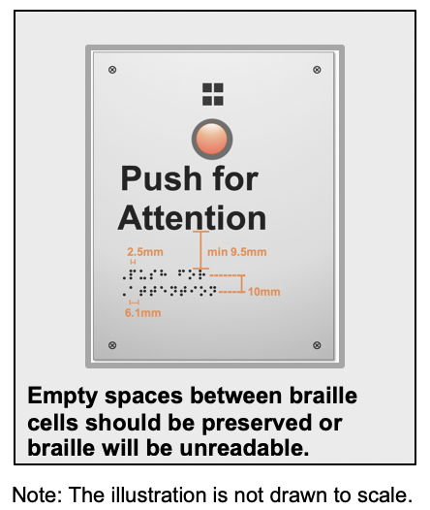
Note: signage fabricated outside of Canada may not conform to the Canadian standards, ensure that the above specifications are used.

2.2 Technical Specifications: Braille Configuration on Signage
- Empty spaces between braille cells must be preserved or the braille will be unreadable.
- The standard for braille in Canada is Unified English Braille (UEB). It is essential to ensure that signs are produced in UEB.
- Follow print, if words are capitalized in print, then capitalize them in braille.
- For French text, use Code Braille Français Uniformisé (CBFU).
- Braille signs of 10 words or fewer, use uncontracted braille.
- For floor directories, use uncontracted braille.
- For signs of greater than 10 words, use contracted braille only if the sign consists of sentences such as emergency evacuation instructions. Ensure contracted braille follows
UEB rules.
- If text is multi-lined, print and braille should appear in separate blocks. Do not interline the print and braille.
- For multi-lined text place all the braille a minimum of 9.5mm below the entire raised print text.
- For multi-lined braille text, a semi-circular braille indicator may be horizontally aligned with and placed directly before the first braille character. This indicator is not essential.

3. Clear, Raised Print Signage

3.1 Readability by Sight
- The size, type and layout of lettering on signs must be clearly legible.
- Use a clear, simple sans serif typeface with uniform stroke width, wide horizontal proportions and distinct letter forms, including prominent ascenders and descenders and open counterforms. Some examples of suitable typefaces are Verdana, Arial, Futura, Gill Sans, Helvetica, Lucinda Sans, and Trebuchet. Do not use condensed or narrowed print fonts.
- Avoid using italics, stylized print, underlining and block capitals.
- The initial letter of the word should be in uppercase; the whole word should not be capitalized.
- Capitalized initial letters help with letter and word recognition, Example: First Aid Room
- Always ensure the sign background contrasts with the print. Clear colour combinations include black text on a white background, white on black, yellow on black or black on yellow.
- Do not print information over pictures or patterns.
- Characters and their background should be non-reflective.
- For non-tactile print, the size of the text should be related to the distance at which the information is to be viewed. Letters should have a minimum height of 15mm. If signs will be viewed from more than 3m away, the text should have a height of 5mm for each metre of viewing distance. For example, if a sign is designed to be viewed from a 5m distance, text should have a height of 25mm.

3.2 Readability by Touch
- Raised letters should have soft-shouldered edges.
- Letters should be raised from the surface of the sign plate by at least 1mm.
- Letter height should be 16-50mm, that is approximately 48-144 point.
- Minimum spacing between letters should be 2mm.
- Minimum spacing between words should be 10mm.
- Letter stroke thickness should be 2-7mm.
- Do not use engraved print letters. These can be very difficult to read by touch.
- Raised borders and elements should be 10mm minimum from tactile characters.
- Tactile text should be left justified, except for single words which may be centre aligned.
Note: Braille signage should always be verified by a qualified braille reader, who should be compensated for their expertise. This ensures that the braille is absent of errors.

4. Pictograms
- When using pictograms for features like exits or male/female washrooms, use internationally recognized symbols.

- Make sure pictograms are always accompanied by raised print and braille. The pictogram is not sufficient on its own – some people will not know what the picture means.

- Raised arrows can be used to indicate direction. These should appear either at the beginning of a line of text or directly after the text label. Avoid large spaces between arrows and their labels. Where braille is on a separate sign plate, a small, raised arrow should be horizontally aligned with the braille, either directly before or after the braille text.
- Always ensure the sign background contrasts with the pictogram. Clear colour combinations include black text on a white background, white on black, yellow on black or black on yellow.
- Raised pictograms should have soft-shouldered edges and should be raised from the surface of the sign plate by 1mm.

5. Electronic Digital Signage
- Alternate formats must be provided for any type of electronic signage for example, video display terminals must provide alternative formats such as audio, braille and minimum of 16-18 point large-text print.
- Touch screens and any buttons must be mounted 900mm to 1200mm above finished floor, be clearly identifiable by colour from background, where required have tactile text. Touch screen technologies should be universally accessible, which should include tactile and audio-access features for blind, low vision and DeafBlind people.
- Signage that is enhanced with an audio option should include a port or jack for headphones, with ports clearly identified by braille and large print.
- Haptic digital signage which uses vibrations to convey information, should also include braille and large print.

6. French
- For French text use CBFU.
- Use uncontracted braille in all instances for less than ten words of text. Use contracted braille for 10 or more consecutive words of text.
- Use the French language signs for accented letters in braille. For example, in the word conférence, the "e" with the acute accent would be written as dots 123456. The symbol should look like this ⠿.
- Use the universal system of digits. The numeric indicator is written as dots 3456 and is placed in front of the letters a-j. For example, 2016 looks like this ⠼⠃⠚⠁⠋ (Antoine numbers are not used.)
- Where a sign applies equally to both English and French (i.e. a nameplate with just a person's name on it), it is suggested that letters be brailled unaccented for universal recognition.
- Follow all other guidelines regarding placement, spacing and capitalization.
- Sample Words:

conférence
unicode ⠉⠕⠝⠋⠿⠗⠑⠝⠉⠑ simbraille conf=rence

arrêter
unicode ⠁⠗⠗⠣⠞⠑⠗ simbraille arr<ter
Note: For more information on French refer to Appendix 3

Appendix 1: FREQUENTLY ASKED QUESTIONS

Q. What is braille?
A: Braille is a system of touch reading and writing used by people who are blind. Embossed (raised) dots are evenly arranged in rectangular spaces, called cells. A full cell is three dots high and two dots wide. Each cell may contain up to six dots. The dot combinations within a cell make up braille characters that may stand for a single letter of the alphabet, a whole word, a punctuation mark, or other symbols. The meaning and use of the braille characters in English follow the rules from the UEB Code.

Q. What is uncontracted braille?
A: Uncontracted braille (sometimes referred to as grade 1 braille) uses braille characters that represent letters of the alphabet, punctuation, and numbers in almost one-for-one correspondence, as well as common braille indicators such as the capital letter indicator and the numeric indicator.
The word ‘stairs’ in uncontracted braille uses one braille character for each letter, as presented below. As shown in this example, the larger circles represent the dots that are raised.
stairs unicode: ⠎⠞⠁⠊⠗⠗⠎ simbraille: stairs

Q. What is contracted braille?
A: Contracted braille (sometimes referred to as grade 2 braille) uses braille characters symbols found in uncontracted braille. It also includes 180 contractions and short-form words representing groups of letters or whole words that appear frequently in the language.
The word ‘stairs’ in contracted braille uses a single braille character for the letter s and t, as presented below. In Canada, the standard for contracted braille is UEB.
stairs unicode: ⠌⠁⠊⠗⠎ simbraille: /airs

Q: Can I import my braille signage?
A: We encourage you to use Canadian signage companies who make accessible signage locally.
If you do want to import your signs, you need to be aware that some imported signs fall outside the guidelines we recommend. For example, braille signs produced in Japan, Korea, Italy and Sweden use slightly smaller dots and spacing, which can be very difficult to read by those not used to this size of braille. Signs imported from the US may be in contracted braille and omit capitals, these do not comply with our guidelines.
Please check the specifications of all imported signs to ensure that they comply with Canadian standards and follow UEB rules.

Q: Do the signage guidelines in Canada differ from those USA?
A: Yes, there are differences between the US and Canadian signage guidelines and standards. Canadian signage fabricators should refer to this document.

Q: Is there anything I need to be aware of when producing braille numbers?
A: Yes. Braille numbers have a numeric indicator in front of them (see Appendix 2). If your automated braille translation software does not have an option for braille numbers, you will need to contact the Braille Literacy Canada / Littératie Braille Canada or your equipment manufacturer for advice on how to do this. The numbers on a qwerty keyboard do not produce numbers in a braille font.

Q: Where can I get more detailed information on braille?
A: Please contact Braille Literacy Canada / Littératie Braille Canada by email: info@blc-lbc.ca.

Appendix 2: NUMBERS
The Braille Numbers
The six dots of the cell are numbered 1, 2, 3, from top to bottom on the left, and 4, 5, 6, from top to bottom on the right.
Each braille number is preceded by dots 3 4 5 6
1: dot 1
2: dots 1 2
3: dots 1 4
4: dots 1 4 5
5: dots 1 5
6: dots 1 2 4
7: dots 1 2 4 5
8: dots 1 2 5
9: dots 2 4
0: dots 2 4 5

Print:
1 2 3 4 5 6 7 8 9 0

Unicode:
⠼⠁⠀⠀⠼⠃⠀⠀⠼⠉⠀⠀⠼⠙⠀⠀⠼⠑⠀⠀⠼⠋⠀⠀⠼⠛⠀⠀⠼⠓⠀⠀⠼⠊⠀⠀⠼⠚
Simbraille:
#a #b #c #d #e #f #g #h #i #j

Examples of braille numbers combined with letters in English

Print: | Unicode: | Simbraille:
420 | ⠼⠙⠃⠚ | #dbj
375A | ⠼⠉⠛⠑⠠⠁ | #cge,a
97bb | ⠼⠊⠛⠰⠃⠃ | #ig2bb
91r | ⠼⠊⠁⠗ | #iar
Lab16 | ⠠⠇⠁⠃⠼⠁⠋ | ,lab#af
Rooms 15-83 | ⠠⠗⠕⠕⠍⠎⠀⠼⠁⠑⠤⠼⠓⠉ | ,rooms #ae-#hc

Note: Braille numbers are in the upper 4 dots of the braille cell. The number sign indicator must precede each number.

When numbers and print are written together
- The capital indicator sign precedes letters that are capitalized (375A)
- The letter sign indicator precedes lower case letters a-j, that immediately follow a number to avoid it being misread as a number (97bb)
- Letter sign indicator is not required for letters k-z that immediately follow a number (91r)
- The number indicator sign precedes each number (Lab16)

Appendix 3: FRENCH

Accented letters in unicode and simbraille
Symbol | Description | Dots | Unicode | Simbraille
â | a circumflex | 1 6 | ⠡ | *
à | a grave | 1 2 3 5 6 | ⠷ | (
ç | c cedilla | 1 2 3 4 6 | ⠯ | &
é | e acute | 1 2 3 4 5 6 | ⠿ | =
ê | e circumflex | 1 2 6 | ⠣ | <
ë | e diaeresis | 1 2 4 6 | ⠫ | $
è | e grave | 2 3 4 6 | ⠮ | !
î | i circumflex | 1 4 6 | ⠩ | %
ï | i diaeresis | 1 2 4 5 6 | ⠻ | ]
ô | o circumflex | 1 4 5 6 | ⠹ | ?
œ | o-e ligature | 2 4 6 | ⠪ | [
û | u circumflex | 1 5 6 | ⠱ | :
ü | u diaeresis | 1 2 5 6 | ⠳ | \
ù | u grave | 2 3 4 5 6 | ⠾ | )
æ | a-e ligature | 3 4 5 | ⠜ | >
 | capital sign | 4 6 | ⠨ | .
? | question mark | 2 6 | ⠢ | 5
« » | opening/closing quotes | 2 3 5 6 | ⠶ | 7
( | opening parentheses | 2 3 6 | ⠦ | 8
) | closing parentheses | 3 5 6 | ⠴ | 0

Examples of words with accented letters in unicode and simbraille:
English | floor | Conference | STOP | turn right
French | étage | Conférence | ARRÊTER | tournez à droite
Unicode | ⠿⠞⠁⠛⠑ | ⠨⠉⠕⠝⠋⠿⠗⠑⠝⠉⠑ | ⠨⠨⠁⠗⠗⠣⠞⠑⠗ | ⠞⠕⠥⠗⠝⠑⠵⠀⠷⠀  ⠙⠗⠕⠊⠞⠑
Simbraille | =tage | .conf=rence | ..arr<ter | tournez ( droite
Note: French text should use CBFU. Transcription and proofreading should be completed by transcriber with knowledge of the French Braille code.

Appendix 4: EXAMPLE OF SIGNAGE INVENTORY AUDIT

BUILDING: ______________________________
LOCATION DETAIL (ROOM _____, FLOOR _____):
DATE: COMMENTS

General
- Content parallels (says same thing in all languages and formats)
- Language: English, French, Other
- Braille, Raised Print, Pictogram (note all that apply)

Placement
- Located 1400mm-1600mm above the finished floor.
- Consistency of placement, location throughout building
- Location of sign relative to door latch or hinge
- Where there is no wall space to the latch side of the door,
signs placed on the nearest adjacent wall
- Elevator: floor number on frame, leading edge: 1350mm from the ground

Contrast
- Sign contrasts to background wall colour
- Use of high contrast colours for text and background
- Signs on glass have thick border of contrasting colour
- Adequate lighting to maximize sign visibility
- Matte or glare free finish on character, symbols and background

Durability and Maintenance
- Signage material condition
- Replacement required (all braille dots intact)

COMMENTS

Braille Signage
- Braille dots, rounded, dome,
- radius minimum 0.75-0.8mm
- Dot height 0.6-0.9mm
- Distance between 2 dots in same cell 2.3-2.5mm
- Distance between corresponding dots in adjacent cells 6.1-7.6mm
- Distance between corresponding dots from one cell to the cell below 10-10-2mm
- Unified English Braille, UEB standard
- Up to 10 words in uncontracted braille, grade one
- French text: Code braille français uniformisé

Clear, Raised Print Signage
- Font type: Arial, Helvetica, Verdana, other
- Text: Initial upper and lowercase (best practice)
- Text: Full capitalization (not preferred)
Readability by sight
- A matte or glare-free finish for characters, symbols and backgrounds
- Use of high contrast colours for text and background.
Readability by touch
- Font type, soft shoulder edge, embossed not engraved, follows technical specifications
- Left justified
- Braille uncontracted, grade one, follows technical specifications

Pictogram
- Follows technical specifications
- Accompanied by equivalent visual
- Accompanied by equivalent raised print
- Accompanied by uncontracted braille

COMMENTS

Electronic Signage
- Format of Alternate text, raised print, braille, pictogram, and/or audio
- Position of alternate text, 900-1200mm above finished floor
- Background contrast for alternate text

Floor number and stair shaft
- Every stairway at each floor level must be clearly identified
by a wall sign on each side of stairway access door.
- Uncontracted braille included
- Include floor level and stair shaft

Exit signs must include:
- Pictogram
- Raised tactile print
- Uncontracted braille
- Mounted on wall latch side of door
- Mounted on wall along accessible escape route

Appendix 5: ACCESSIBLE SIGNAGE CHECK LIST
Braille
- Dot shape, size and height (page 10)
- Distance between dots, cells and lines (page 10)
- Unified English Braille including numbers (pages 12, 17, 19-20)
- Code braille français uniformisé:French Braille (pages 12, 16, 21)
- Braille same as print (page 4)
- Uncontracted, grade 1, braille for ten words or less (pages 12, 16)
- Multi-lined braille and braille indicator (page 12)
- Imported signage compliance (page 11, 18)
- Capitalization follows print (page 12, 16)
- Left Justified (page 9,14)

Readability by Touch, Arrows, Indicators, Borders, Pictograms
- Soft-shoulders for raised letters (page 14) and pictograms
(pages 14-15)
- Pictograms accompanied by equivalent print and braille
(page 14)
- Pictograms use standard symbols (page 14)
- Letter size and height from surface (page 14)
- Letter stroke thickness (page 14)
- Distance between letters and words (page 14)
- Distance away from braille and other tactile elements (page 14)
- Capitalization (page 14)

Readability by Sight
- Font size and style (page 13)
- Capitalization (page 13)

Contrast, Layout, Durability and Placement
- Contrast and glare (pages 4, 9, 13, 15)
- Background (page 9, 13, 15)
- Braille and print left justified (page 9, 14)
- Braille below print (page 4, 9)
- Durable materials used (page 10)
- Placement of sign (pages 5-8)

REFERENCES
Accessible design for the built environment - CSA/ASC B-651:23 January 2023, National Standard of Canada published by CSA Group 178 Rexdale Boulevard, Toronto, ON M9W 1R3
ISBN 978-1-4883-4659-0

Accessible Signage Guidelines, Second Edition, 2018
Copyright Royal New Zealand Foundation of the Blind 2018., Auckland, New Zealand: The Royal New Zealand Foundation of the Blind. Copyright Royal New Zealand Foundation of the Blind 2013. ISBN: 978-1-877138-10-2

ADA Standards for Accessible Design (2010), United States Department of Justice. www.ada.gov/regs2010/2010ADAStandards/2010ADAstandards.htm

ADAAG Manual – a guide to the American with Disabilities Accessibility Guidelines (reprinted 2004)
www.access-board.gov/ada/chapter/ch07/

Canadian Human Rights Act (R.S.C., 1985, c. H-6), Act current to 2016-02-03 and last amended on 2014-11-01, Government of Canada. laws-lois.justice.gc.ca/eng/acts/H-6/

CMHC Universal Design A guide for designers, builders and developers of multi-unit residential buildings (2022)
www.cmhc-schl.gc.ca/professionals/industry-innovation-and-leadership/industry-expertise/accessible-adaptable-housing/universal-design-new-multi-unit-residential-buildings

Convention on the Rights for Persons with Disabilities (2006), United Nations.

Design Resources DR-11 Text legibility and Readability of large Format Signs in building and Sites (2010), Center for Inclusive Design and Environmental Access, University at Buffalo School of Architecture and Planning.

Guideline on the Application of the Premises Standards (v2, 2013) Australian Human Rights Commission
ICC/ANSI A117.1-2003 Accessible and Useable Buildings and Facilities (First Version, 2011), ICC/ANSI.

National Building Code of Canada:2020, (15th edition, 2020) National Research Council of Canada

New Zealand Standard 4121:2001 Design for Access and Mobility – Buildings and Associated Facilities (2001), Standards New Zealand – Paerewa Aotearoa.

Nova White Papers – Accessibility Series: Canada, Nova Polymers, Inc. (2014)
Progress Report on Implementation of “Nothing Without Us”: Accessibility Strategy for the Public Service of Canada (2021) www.canada.ca/en/government/publicservice/wellness-inclusion-diversity-public-service/diversity-inclusion-public-service/accessibility-public-service/accessibility-strategy-public-service-toc/progress-report-implementation-nothing-without-us-2019-20.html
See it Right: Making information accessible for people with sight problems (2006), Royal National Institute of the Blind, London.

Size and Spacing of Braille Characters (2010), Braille Authority of North America. www.brailleauthority.org/sizespacingofbraille

Canadian Provincial Resources
British Columbia – Accessibility Requirements for BC Building Code, (2018)
British Columbia – Building Accessibility Handbook 2020
Manitoba - Accessibility Advisory Council: Recommendations for an Accessibility Standard for the Design of Public Spaces (2020)
Nova Scotia – Recommendations to the Government of Nova Scotia on Accessibility Standards in the Built Environment: Phase 1, (2020)
Ontario – A Guide to the Accessibility for Ontarians with Disabilities Act, (AODA 2005)
Ontario – Guidelines for Barrier-Free Design of Ontario Government (2023)
Saskatchewan – The Uniform Building and Accessibility Standards Act -NET, (2021)

