NATIONAL GUIDELINES FOR THE PRODUCTION OF e-TEXT
Canadian Association of Educational Resource Centres for Alternate Format Materials (CAER)
Contributors:
In Fall 2023, the Canadian Association of Educational Resource Centres for Alternate Format Materials (CAER) (a pan-Canadian group of alternate format producers), convened an internal working group with the goal of creating a set of national guidelines for the production of e-Text materials. Following a rigorous review of current practices, the group developed these National Guidelines for the Production of e-Text. This work would not have been possible without the contributions of the following agencies and individuals:
Alternative Educational Resources Ontario (AERO): Bob Minnery, Karen Nairn.
Atlantic Provinces Special Education Authority (APSEA): Sarah Laird.
Centre for Accessible Post-secondary Education Resources (CAPER-BC): Jennifer Weldon, Daniel Carkner, Sandi Ma.
National Network for Equitable Library Service (NNELS): Riane LaPaire, John Ylioja.
Provincial Resource Centre for the Visually Impaired (PRCVI): Adam Wilton, Nancy Zhang, Corrie Playford.
Service de production braille de la Commission Scolaire des Premières-Seigneuries (CCSPS): Isabelle Grant, Lucie Latouche, Andreanne Simard-Dionne.
Citation:
Canadian Association of Educational Resource Centres for Alternate Format Materials (CAER). (2025). National Guidelines for the Production of e-Text.

NATIONAL GUIDELINES FOR THE PRODUCTION OF e-TEXT
Word Generated Table of Contents:
1.0 Basic Guidelines 5
1.1 Document Proofing 5
1.2 Document Cleanup 6
1.3 Reconfiguring Layout 6
1.4 General Document Formatting 7
1.4.1 Text Emphasis 8
1.5 Tags and Indicators 9
1.6 Producer’s Notes 10
2.0 Front Matter/End Matter 11
2.1 Book Title and Cover 11
Example 2.1.A: Book Cover with Text Content 11
2.2 File Information 12
2.2.1 Agency Disclaimer/Copyright Statement 12
2.2.2 Producer’s Title Page 12
2.2.3 Producer’s General Notes 13
2.3 Front Matter 13
2.4 Table of Contents - Original Print 13
2.5 Other Front/End Matter 14
Example 2.5.A: Inside Front Cover with Meaningful Content 14
2.6 Back Matter 15
3.0 Navigation 16
3.1 Word-Generated Table of Contents 16
3.2 Pagination 16
3.3 Blank Page 17
3.4 Headings 17
3.5 Context Breaks 19
3.6 End of File 19
3.7 Hyperlinks 19
4.0 Non-Text Content 20
4.1 Visual Elements 20
Example 4.1.A: Placement of Producer’s Note in Tags for Visual Media 23
Example 4.1.B: Placement of Caption for Visual Media 24
Example 4.1.C: Use of Specific Visual Media Tags 25
4.2 Cartoons 26
Example 4.2.A: Cartoon Strip 26
4.3 Icons and Emojis 27
4.4 Tactile Supplements 28
Example 4.4.A: Producer’s Note Referring to a Tactile Supplement 28
5.0 Punctuation and Special Characters 30
5.1 Non-English Characters 30
5.2 Quotation Marks 30
5.3 Hyphens and Dashes 31
5.4 Ellipsis 31
5.5 Numbers 31
6.0 Page Layout 33
6.1 Indentation 33
Example 6.1.A: Code with Indentation Levels 33
6.2 Text Boxes 33
Example 6.2.A: Text Box Interrupting Flow of Main Text 34
6.3 Sidebars 35
6.4 Definitions and Key Terms 36
7.0 Data Organization 37
7.1 Tables 37
Example 7.1.A: Complex Table Inserted using Table Function 37
Example 7.1.B: Complex Table Inserted as Text 39
7.2 Lists 40
Example 7.2.A: Lists Separated by Headings 41
8.0 Content-Specific Guidelines 43
8.1 Annotations 43
8.2 Multiple Languages within the Same Document/File 43
8.3 Superscript and Subscript 43
8.4 Workbooks, Worktexts 43
8.5 Poetry Content 44
Example 8.5.A: Maintaining Spatial Formatting in Poetry 45
8.6 Mathematical/Technical Content 46
9.0 Notes 47
9.1 Footnotes/Endnotes 47
Example 9.1.A: Footnotes 47
10.0 Templates and Resources 49
10.1 Producer’s Title Page Template 49
10.2 Producer's General Notes Template and Conditional Statements 50
10.2.1 Standard Producer's General Notes Template 50
10.2.2 Conditional Statements for Producer’s General Notes 51
10.2.3 Content-Specific Statements for Producer’s General Notes 51
10.3 Commonly Used Tags and Indicators in e-Text 52
10.4 Producer Resources 55
10.4.1 Alt Codes to Enter Special Characters 55
10.4.2 Useful Authoring Tools/Software 55
10.2.4: Working with text styles in Word 57
10.5 Glossary 58
11.0 Reference Content 60

These guidelines are presented to provide alternate format producers with a common set of practices. They are intended to promote consistency in e-Text production across Canada. Throughout the style sheet, the following language conventions apply:
- Use of the word “must” indicates an obligation. The e-Text producer is required to follow the guideline as written.
- Use of the word “should” indicates a recommendation. The e-Text producer is urged to follow the guideline as written but not obligated.
- Use of the word “may” indicates an option. It supplies an option the e-Text producer could choose at their discretion.
Within this style sheet, internal links to sections, subsections, or examples are provided with the number, title, and a short description. External links to websites or other sources of information are also provided and were checked for accuracy at the time of publication.

1.0 Basic Guidelines
This section addresses broad cleanup and formatting guidelines used in the preparation of e-Texts and provides information on helpful editing tools.

1.1 Document Proofing
- Use professional Optical Character Recognition (OCR) software such as OmniPage or ABBYY FineReader to process PDF documents or scanned books for e-Text editing, except in cases where born-digital documents already contain the integral text with usable formatting.
- Verify the e-Text against the original print or digital source document (referred to as “original print” throughout this style sheet for brevity) to ensure it is reproduced with complete fidelity to the text in the original print.
  - Errors in the original print (e.g. typos) are maintained in the e-Text to maximize consistency in reader experience between versions.
- Ensure the language settings in the e-Text match the language of the original print.
- Remove or correct any errors or broken formatting introduced by the OCR software.
  - Lines of text or paragraphs are occasionally broken up during OCR and must be brought together to match the original print version.
  - OCR errors which substitute a similar character for another one must be corrected (e.g. 0 replacing O, 1 replacing letter l, vv replacing w, rn replacing m, and so on).
  - Tab spacing, extra blank lines, and other formatting inserted by the OCR software must be removed if they conflict with the guidelines set out in this style sheet.
- Spell check may be used by the producer as part of the editing process to check OCR errors, etc. Grammar check should not be used.
  - Ensure spell check does not correct typographical errors from the original print in the e-Text.
  - Be aware of regional spelling variations, which must also follow the original print (e.g. the word colour spelled with a “u” in UK and Canadian English and without the “u” (color) in US English).
  - Manual review is required by the producer when using any automated tool to make bulk changes to the e-Text (e.g. use of a macro to remove extra spaces).
  - Special attention must be applied to words in languages other than English within an English e-Text as AutoCorrect will not recognize these words. Manually “skip” the automatic correction of these words.
- Enable Show/Hide Formatting symbols in the Home toolbar while editing . This displays all spaces, soft returns and hard returns, and other formatting in the e-Text (refer to 10.5 Glossary for definitions of soft and hard returns).
- Autocorrect and auto-format functions in Microsoft Word (Word) may be used. If these functions negatively impact the reading experience, producers can modify their autocorrect and auto-format settings in Word.
  - Autocorrect can be set up to help complete language tags (e.g. pr changes to PRINT PAGE, bc changes to BEGIN CAPTION, etc.) if desired. Refer to 1.5 Tags and Indicators for more information about tags.

1.2 Document Cleanup
- Omit running headers/footers, watermarks, and digital stamps from the e-Text if they are used in the original print.
- Insert special characters using Unicode symbols whenever possible, unless otherwise specified within this style sheet. Support for the correct reading of these symbols has improved over time (refer to 5.0 Punctuation and Special Characters).
- Conduct a final proofing quality check of the entire e-Text to identify all formatting errors or omissions. This check is essential to ensure that nothing has been missed and that the guidelines and formatting have been applied consistently from start to finish.
  - This proofing process should check to ensure all tags are properly closed, all print page number indicators are included, and agency or producer decisions have been consistently applied, etc. It is not intended as a full word by word proofreading of the entire e-Text.
  - Review the navigation pane to ensure that heading styles have been appropriately applied throughout the document. For example, a blank entry in the navigation pane may indicate that a heading style was incorrectly applied to a hard return.
- Following the manual proofing check, the Accessibility Checker tool in Microsoft Word can be used optionally to identify simple accessibility issues such as visual media with no alt text. This tool will not identify all accessibility issues and should not be used in placed of a detailed proofing by the producer.

1.3 Reconfiguring Layout
- Content must not be moved from the original print page in the e-Text, except in the following specific cases:
  - If a word starts on one page and ends on the next one in the original print, the last part of the word must be brought back to the preceding page in the e-Text.
  - If a hyphen is used to join a word broken over two lines in the original print, the hyphen must be deleted to form a complete word. Hyphens placed at the end of a line must be retained if they are part of a compound word in the e-Text (e.g. son-in-law, over-the-counter).
  - If a large page element (e.g. table, text box, list, etc.) significantly interrupts the flow of the main text in the original print, the producer may bring the paragraph together on either the previous or following page. The placement of the element is at the producer’s discretion and requires a Producer’s Note to communicate this change to the reader (refer to 1.6 Producer’s Notes).
    - Alternatively, the producer may use their discretion to leave the large page element in the e-Text as reflected in the original print. Add a Producer’s Note that reads "continues on print page #" prior to the tag indicating the start of the large print element (refer to 1.5 Tags and Indicators and Example 6.2.A: Text Box Interrupting Flow of Main Text).
  - If a short list is broken by pagination in the original print and there are one or two list items on the next page, in the e-Text it must be rejoined on the original print page on which the list begins (refer to 7.2 Lists).
  - If text in a sidebar, or text box crosses two pages in the original print and would interrupt or be interrupted by the flow of the main text (e.g. a text box that horizontally crosses the bottom of two facing pages), it should be brought together on one of the two pages (refer to 6.3 Sidebars or 6.2 Text Boxes).
  - If text in a heading crosses two pages in the original print but is meant to be read as one heading (e.g. the title of a chapter that horizontally crosses the top of two facing pages), the heading in the e-Text must be brought together in the location where it should be read (e.g. on the print page at the beginning of the chapter).

1.4 General Document Formatting
- Save files in .docx format.
- Use consistent and informative file naming conventions. At minimum, useful information includes: a leading number to indicate sequence (e.g. volume number), title, and page numbers and/or chapters contained in that file.
  - Use of underscores, spaces, or neither between file name segments is at the agency or producer’s discretion (e.g. “02_AnneOfGreenGables_p85-263.docx”).
- e-Texts may be saved as one file or multiple files at the agency or producer’s discretion.
- A Producer's General Note (PGN) must be included at the beginning of every e-Text file (refer to 2.2.3 Producer’s General Notes and 10.2 Producer’s General Notes Template and Conditional Statements).
- Set the "Normal" style in the e-Text to 12-point black text on white background. The producer may choose the font type as long as it is legible and commonly available.
  - Headings and other styled content may have different font size and types applied, but font colour must be set to black on white. Word often styles headings in blue font by default. For more information refer to 3.4 Headings.
  - Hyperlinks within the e-Text should be automatically formatted to blue underlined text as this is highly recognizable to visual readers.
- Paragraphs of text from the original print must be entered in the e-Text with only a single hard return at the end of each paragraph.
  - Set spacing before paragraphs to 0-point. Set spacing after paragraphs to 12-point. Do not create extra spacing between normal paragraphs using hard or soft returns.
  - Remove extra spaces and blank lines that serve a visual and/or aesthetic function in the original print but do not contain meaning or significance to the text.
    - In some cases, extra blank lines may be retained. For example, in poetry (refer to 8.5 Poetry Content) or for breaks in context (refer to 3.5 Context Breaks).
- Text content in the e-Text must be set to the correct language in Word (e.g. English (Canada), French (Canada), Vietnamese, etc.). When setting the proofing language, the producer must uncheck the “Detect language automatically” box. For more information, refer to 5.1 Non-English Characters and 8.2 Multiple Languages within the Same Document/File.
- The e-Text must not contain page breaks, with the following exception:
  - Word might automatically insert a page break following the Word-Generated Table of Contents. If this occurs, this page break can be left in the e-Text.
- The e-Text must not contain any Tab spacing, with the following exceptions:
  - Maintain the original Tab spacing for content where indentation levels are meaningful, such as reference citations in a specific style or an original containing examples of programming languages (refer to 6.1 Indentation).
- The e-Text must be produced entirely with left alignment and line spacing set to “1.15 lines”, with the following exceptions:
  - Utilize the default settings for styled elements in Word such as lists and headings.
- Visual formatting and other page elements must be identified in the e-Text with Tags or Indicators so that essential information is communicated to the reader (refer to 1.5 Tags and Indicators).

1.4.1 Text Emphasis
- Text emphasis in the e-Text must utilize the built-in Word styles rather than applying the bold or italic text attributes. Applying these styles ensures that the purpose of the text emphasis is announced to the non-visual user via screen reading software. For more information refer to 10.4.2 Useful Authoring Tools/Software.
  - Style bold text as Strong.
  - Style italic text as Emphasis.
  - Style underlined text as Emphasis and apply Underline as a text attribute.
  - Styles are applied to punctuation only if the text emphasis is applied to punctuation in the original print.
  - Where bold is used to set apart a heading or key term in the original print and there is no punctuation, put a colon (:) at the end of the bold section in the e-Text and style the heading or key term as Strong (e.g. “Personalized Marketing A vivid and accurate…” becomes “Personalized Marketing: A vivid and accurate …”).
    - The Strong style should be applied to the heading or key term but not to the added colon.
  - When specific types of content are indicated by text emphasis or formatting in the original print (e.g. letters are in italic text, excerpts from other books are indented and bold text), use the appropriate tags or indentation to mark this content in the e-Text instead of text emphasis or styles. Refer to 1.5 Tags and Indicators, 6.1 Indentation, and 8.0 Content-Specific Guidelines.

1.5 Tags and Indicators
- Text markers called tags are used in the e-Text to identify visual media and page elements whose purpose and function are communicated to the reader in the original print with formatting and layout information.
- Tags consist of two parts: an opening tag “BEGIN ___:”, and a closing tag “END ___.” and enclose the content they identify.
  - For example: if the original print contains a text box surrounded by a line and placed on the top half of a page, in the e-Text the content and function of this text box would be indicated to the reader using tags:
BEGIN TEXT BOX:↵
See the end of this chapter for more cool experiments!↵
END TEXT BOX.¶
- A soft return separates the opening tag from the following content. Soft returns are used so that a 12-point space is not inserted between the tag and the text enclosed in the tag. A hard return follows the closing tag.
  - When using built-in Word formatting for a list or table, a hard return must be used after the tag to separate it from the list or table. Hard returns are necessary to ensure the tags are not styled as part of the list or table.
- Refer to 10.3 Commonly Used Tags and Indicators in e-Text for a list of commonly used tags and indicators.
- When required, a producer may create new tags. Producer-generated tags must follow the same formatting convention as standard tags and must be applied consistently throughout the e-Text.
- Indicators are also a type of text marker but consist of a single part (i.e. they do not consist of an opening tag and a closing tag).
  - The most common indicators inserted into the e-Text are PRINT PAGE # and BLANK PAGE. Refer to 3.2 Pagination and 3.3 Blank Page for more information.
- A hard return separates PRINT PAGE indicators from the text immediately before and after, with the following exceptions:
  - When using built-in Word formatting as discussed above, the PRINT PAGE indicator must be preceded by a soft return and followed by a hard return (to prevent the formatting from being applied to the indicator) (Refer to 7.2 Lists).
  - When the PRINT PAGE indicator interrupts a paragraph of text, it must be separated from the surrounding text with soft returns before and after the indicator. For example:
‘There, there, Marilla, you can have your own way’ said Matthew reassuringly. ‘Only be as good and kind to her↵
PRINT PAGE 68↵
as you can be without spoiling her.¶
- Indicators other than page number and blank page are contained within square brackets and are not separated from the surrounding contents by soft or hard returns (refer to 1.6 Producer’s Notes).

1.6 Producer’s Notes
- Producer’s Notes are used to alert the reader to changes from the original print that the producer has made in the e-Text. These comments, inserted into the e-Text by the producer to indicate special handling of text, description of images, etc., must be surrounded by the tags BEGIN/END PRODUCER'S NOTE.
- There are limited instances where the producer may insert new content into the e-Text without the use of a Producer’s Note.
  - These producer inserts are a type of indicator used for short content when using a Producer’s Note would unnecessarily interrupt the reading experience. They must be inserted into the e-Text in-line with the surrounding text and are enclosed within square brackets.
  - Examples of producer-added indicators enclosed in square brackets include:
    - In-line footnote or endnote indicators (e.g. [FOOTNOTE 32])
    - Blank spaces in fill-in-the-blanks exercises in the original print are replaced with the [BLANK SPACE] indicator.
    - A symbol (e.g. a purple diamond) used to indicate a fun fact in a Social Studies textbook is replaced with [FUN FACT].

2.0 Front Matter/End Matter
This section addresses both front and end matter in the original print (e.g. verso/publisher information) as well as sections that are specific to e-Text (e.g. Producer’s Title Page).
- Book Title
- Book Cover
- File Information
  - Agency Disclaimer/Copyright Statement
  - Producer’s Title Page
  - Producer’s General Notes
  - Word-Generated Table of Contents
- Front Matter
  - Title Page – Original Print
  - Table of Contents – Original Print
  - Other Front/End Matter
- Back Matter (following main body of text/contents of original print)

2.1 Book Title and Cover
- Begin each e-Text file with the title of the original print, styled as Heading level 1 (Refer to 3.4 Headings).
- If the original print has no front cover, refer to 2.2.2 Producer’s Title Page.
- Any text on the front cover that is pertinent to the content of the original print must be retained in the e-Text (Refer to Example 2.1.A: Book Cover with Text Content).
- Include an image of the front cover of the original print (if it has one).

Example 2.1.A: Book Cover with Text Content
Excerpted from Ladner, Wayne (2004).
Physics 12
Student Notes and Problems [Note: Apply heading style 1 to book title]
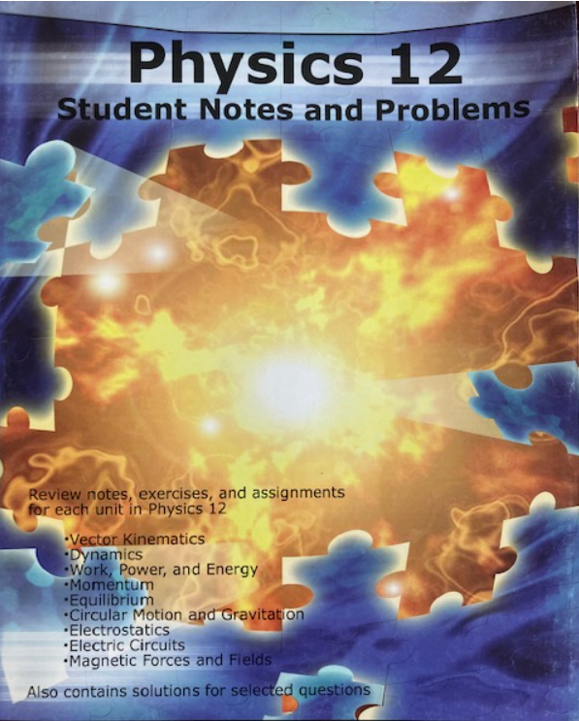
BEGIN FRONT COVER:
Review notes, exercises, and assignments for each unit in Physics 12
BEGIN LIST
- Vector Kinematics
- Dynamics,
- Work, Power, and Energy
- Momentum
- Equilibrium
- Circular Motion and Gravitation
- Electrostatics
- Electric Circuits
- Magnetic Forces and Fields
END LIST
Also contains solutions for selected questions
END FRONT COVER.

2.2 File Information
The following subsections refer to agency-specific additions to the e-Text. They must be included in the order listed below, following the label “File Information” styled as Heading Level 2 (Refer to 3.4 Headings).

2.2.1 Agency Disclaimer/Copyright Statement
- The Agency Disclaimer/Copyright statement must be placed at the beginning of each individual e-Text file.
- It provides details to the reader about the Agency that produced the e-Text, including contact information, as well as details about appropriate use of accessible materials for individuals with print disabilities as outlined in the Canadian Copyright Act. For example:
Appropriate Use Statement [Note this text must be styled as Heading Level 3]
AGENCY LOGO
AGENCY NAME creates high-quality files in digital alternate formats for students with perceptual disabilities in accordance with Section 32(1) of the Copyright Act [R.S.C., 1985, c. C-42]. Further distribution or reproduction of this material must comply with this Act. All rights reserved. For more information see AGENCY WEBSITE.
If any errors are identified in this document, please contact AGENCY NAME at AGENCY CONTACT INFORMATION.

2.2.2 Producer’s Title Page
- The Producer’s Title Page is provided at the beginning of each individual e-Text file, with “Producer’s Title Page” styled as Heading Level 3 (Refer to 3.4 Headings).
  - If the original print has no front cover add the book title to the top of the first page of the file, styled as Heading Level 1.
- The Producer’s Title Page lists complete publication details of the original print, as well as production information for the specific e-Text.
- e-Text produced using the guidelines in this style sheet must include the template in 10.1 Producer’s Title Page Template. Additional information may be added at the discretion of the producer and/or agency.

2.2.3 Producer’s General Notes
- The Producer’s General Notes (PGN) section is included in each individual e-Text file, with “Producer’s General Notes” styled as Heading Level 3 (Refer to 3.4 Headings).
- The PGN is to inform the reader of various e-Text conventions while also serving as a record of agency or producer decisions specific to the individual e-Text production.
- The PGN includes navigation tips and strategies, explanations for the use of tags, and detailed information on any production decisions that result in a departure from the formatting and layout of the original printed work.
  - For example: the PGN of a book of poetry should prompt the reader to adjust the verbosity settings of their screen reading software to announce punctuation and spaces, as both might be informative in a poem.
- e-Text produced using the guidelines in this style sheet must include the template PGN in 10.2.1: Standard Producer’s General Notes Template. Refer also to 10.2.2: Conditional Statements for Producer's General Notes and 10.2.3 Content-Specific Statements for Producer’s General Notes.

2.3 Front Matter
- In an e-Text production, all content in the original print that is before the table of contents is considered Front Matter. If there is no table of contents in the original print, Front Matter is all content that is before the main body content (i.e., Chapter 1, Unit 1).
- Original print title pages and other front matter (e.g. half-title page, title page, colophone/publisher information, dedication, etc.) are retained in the order they are presented in the original print and follow the PGN.
- Insert the heading “Front Matter” styled as Heading Level 2 (Refer to 3.4 Headings) at the beginning of the original print title pages, with a Producer’s Note indicating that the heading has been added and is not present in the original print at the beginning of the original print title page.
- Use the appropriate tags to indicate the individual types of content (e.g. BEGIN/END TITLE PAGE, BEGIN/END DEDICATION). Refer to 1.5 Tags and Indicators and 10.3 Commonly Used Tags and Indicators in e-Text.

2.4 Table of Contents - Original Print
- The Table of Contents (TOC) - Original Print is the text of the TOC as presented in the original print, as opposed to the hyperlinked list of headings generated by Word (for more information refer to 3.1 Word-generated Table of Contents).
- Use BEGIN/END TABLE OF CONTENTS tags to indicate the Original Print TOC.
- Do not hyperlink the print TOC to the relevant sections in the e-Text. The Word-generated table of contents provides hyperlinked navigation within the e-Text.
- Format the Original Print TOC as it is presented in the original print.
- Place an ellipsis (…) with a space on either side between TOC title and page number in the e-Text, regardless of how it is presented in the original print.

2.5 Other Front/End Matter
- Other front or end matter in the original can include the front cover, back cover, dust jackets (including inner flaps), inside front cover, inside back cover, etc.
- Generally, information contained in these types of front and end matter is retained per producer’s discretion if it is judged to be pertinent to the content (e.g. “Three stories in one book!”), but omitted if it is not pertinent to the content (e.g. ratings or blurbs by other authors printed on the cover, stickers indicating “Soon to be a major motion picture!”).
- In the e-Text, if these materials are retained, they must follow the same order they are presented in the original print.
- If the inside front or back cover of the original print contains important information, include it in the e-Text and use the BEGIN/END INSIDE FRONT COVER or BEGIN/END INSIDE BACK COVER tags (refer to Example 2.5.A: Inside Front Cover with Meaningful Content).

Example 2.5.A: Inside Front Cover with Meaningful Content
Portion of inside front cover excerpted from Mader and Windelspecht (2014):
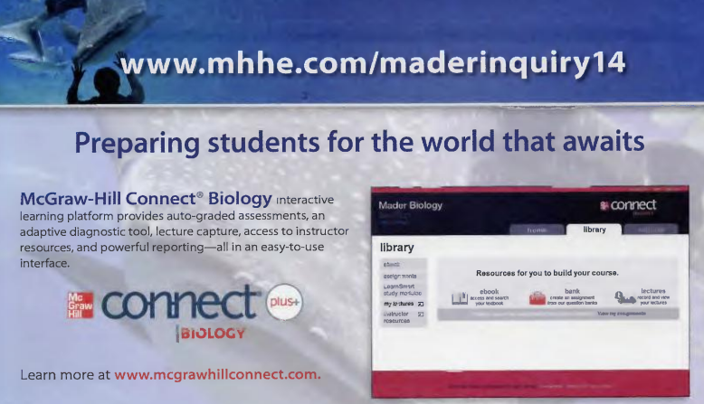
BEGIN INSIDE FRONT COVER:
www.mhhe.com/maderinquiry14
Preparing students for the world that awaits
McGraw–Hill Connect® Biology interactive learning platform provides auto–graded assessments, an adaptive diagnostic tool, lecture capture, access to instructor resources, and powerful reporting–all in an easy–to–use interface.
BEGIN BOXED MATERIAL:
McGraw Hill connect plus+ BIOLOGY
END BOXED MATERIAL.
Learn more at www.mcgrawhillconnect.com.
END INSIDE FRONT COVER.

2.6 Back Matter
- Back matter in the original can consist of a variety of materials, including the index, glossary, answer key(s), etc.
- In the e-Text, these materials should follow the main body of text in the original, in the same order they are originally presented.
- Apply the list style to the index from the original print in the e-Text for ease of navigation.
- For further information on endnotes and references, refer to 9.1 Footnotes/Endnotes

3.0 Navigation
The sections that follow outline the elements that add a navigable structure to the e-Text.

3.1 Word-Generated Table of Contents
This Table of Contents is auto-generated in the e-Text by Word based on the heading structure of the document. Although it covers the same content, it is distinct from the Table of Contents which is present in the original print. The Word-generated TOC will not automatically update following changes made in the file. The producer should either update the Word-generated TOC regularly following changes made to the e-Text file or insert the Word-generated TOC as one of the final steps in the production process.
- The Word-generated TOC must immediately follow the PGN.
  - If the e-Text version of the original print is composed of multiple .DOCX files, a Word-generated TOC for each individual e-Text file must be inserted following the PGN in each component .DOCX file.
- Add the title “Word-Generated Table of Contents” at the top of the Word-generated TOC, styled as Heading Level 3 (Refer to 3.4 Headings).
- The Word-generated TOC will contain page numbers that refer to e-Text pages and not the original print. e-Text page references and hyperlinking allow the reader to navigate to specific sections of the e-Text.
- Insert the Word-generated TOC immediately following the PGN using the following steps:
  - In the References ribbon, expand the Table of Contents dropdown menu and select "custom table of contents".
  - Click the "Modify" tab and set up the font type and size to match the font type and size used in the rest of the e-Text.
  - Ensure that “Show page numbers” is checked.
  - Change the "show levels" to 1 (or to 2 or 3 depending on the number of headings used).
  - Click "ok".

3.2 Pagination
- The location of content in the original print must be noted by a PRINT PAGE indicator followed by page number (e.g. PRINT PAGE 12). Note that there is no style applied to this PRINT PAGE indicator.
- The PRINT PAGE indicator in the e-Text must be placed before the page content, regardless of where the page numbers are located on the original print page.
  - If a page is not numbered but is a part of the overall pagination, the producer should add a print page indicator contained within square bracket
  - If a page is not numbered, is not part of the overall pagination, and contains content, the producer should reflect this in a Producer’s Note. For example:
[PRINT PAGE]
BEGIN PRODUCER’S NOTE:
This page is unnumbered and is not part of the total number of pages in the original print.
END PRODUCER’S NOTE.
  - If a page is not numbered, is not part of the overall pagination, and contains no content, the producer should omit the page.
- The PRINT PAGE indicator must have a hard return inserted above and immediately following.
  - There are two exceptions to this requirement:
    - If the page break happens mid-paragraph, the PRINT PAGE indicator must be separated from the text using soft returns only.
    - If the PRINT PAGE indicator is inserted in a list, the indicator is separated from the adjacent list item with soft returns. Avoiding separation using hard returns prevents the PRINT PAGE indicator from being styled as an individual list item when the List style is applied.
- Roman numerals in the original print that are used as page numbers must be retained as Roman numerals in the e-Text.
  - Other types of page identifiers used in the original print must be retained in the e-Text (e.g. Page B156).
  - The retention of page identifiers from the original print should be noted in the PGN.
- In the case of course packages where pages are omitted or presented out of print order, it must be mentioned in the PGN.

3.3 Blank Page
- Use the BLANK PAGE indicator for any blank page that falls within the pagination of the original print. The [BLANK PAGE] indicator is enclosed by square brackets.
PRINT PAGE 345
[BLANK PAGE]
PRINT PAGE 346
This is sample adjacent text.

3.4 Headings
- Use Word’s built-in heading styles to maintain the section and subsection structure in the original print. Do not add blank lines before or after headings.
  - The producer must set the visual formatting of heading styles to black (blue is the default setting in Word). The Microsoft support website provides more information on editing the visual formatting of default heading styles within Word. Font style, size, and other attributes are applied to headings at the discretion of the producer provided they are consistently applied throughout the e-Text.
- The producer must use a soft return to keep the text as a single heading if components of the chapter or section title text are arranged on different lines on the page in the original print,
  - Chapter information should be read in an informative and intuitive sequence. The producer may rearrange these elements at their discretion. For example, if the chapter number is separated from “CHAPTER” and is placed in the upper corner of the page in the original print, it must be brought together as CHAPTER 12 in the e-Text.
- Use heading styles in sequential order to add navigable structure to the e-Text and indicate major sections and subsections of the original print.
  - The producer may use heading styles up to Heading 6 if needed. Do not use heading styles beyond Heading 6. In the case that the section and subsection structure of the original print uses headings beyond Heading 6, apply Heading 6 to all subsequent levels. Include a note in the PGN if the heading structure in the original print uses levels beyond level 6 Headings.
  - Do not use “Title” heading style in Word as it will not be incorporated into the e-Text’s navigation pane. The title of the original print must be styled as Heading 1 and is included at the beginning of each individual e-Text file.
- If the e-Text is split into multiple files (e.g. chapters or sections), the heading structure must be maintained as though it were one file (e.g. if chapter titles are set as Heading 2 and the book is split into individual chapter files, the Heading 2 style will be maintained on chapter titles across all files).
- If the original print is split into individual chapter files and the reader will only require certain chapters, the superordinate navigation must be included in each individual e-Text file (e.g. Unit C Characteristics of Electricity Cont’d. Chapter 9 Static Electricity cont’d. 9.1 Types of Electricity).
  - For example: A classroom teacher uses chapters 2 and 7. In this case, the reader would still need the unit name or section title from the original print in these individual chapter files.
- Any short-form materials (e.g. instructor generated materials including handouts, class notes, tests, presentation materials, course packs, etc.) should have identifying information at the top of the file, such as title or file name. This information does not have to be styled as a heading unless there is navigational benefit. If no such information exists, producers can include a Producer’s Note to identify material.
- Identify any navigational headings that are not part of the original print in a Producer’s Note. The Producer’s Note must contain the heading so it is clear to the reader that this heading was added by the producer and is not present in the original print. For example:
BEGIN PRODUCER’S NOTE:
Learning Objective Questions
This heading has been added by the producer for ease of navigation and is not present in the original print.
END PRODUCER’S NOTE.

3.5 Context Breaks
- In the original print, context breaks may be represented by symbols, blank lines, illustrations, etc. In the e-Text, these indicators are removed and replaced with three asterisks, each separated by one space (* * *) The group of asterisks is placed on a line by itself, preceded and followed by hard returns.
- Context breaks which are the result of missing or omitted pages must be noted by a Producer’s Note.
- Context break representation must be noted in the PGN to ensure the reader will consistently associate three spaced asterisks with a context break. It is at the producer’s discretion as to whether the formatting of context breaks in the original print is described in the PGN.
  - If three spaced asterisks are used for another reason in the original print, three spaced daggers († † †) may be used to represent context breaks in the e-Text. This must be reflected in the PGN.

3.6 End of File
- At the end of each separately saved file, type [END OF FILE] and specify the file number and total number of files. If the title is partially produced (e.g. 2 of 7 chapters), the [END OF FILE] statements in each individual file must be updated to reflect the total number of files produced at that time (e.g. [END OF FILE 6 OF 18]).
  - If subsequent files are produced later, the producer of those files must update the [END OF FILE] indicator in all existing files.

3.7 Hyperlinks
- All URLs must be hyperlinked within the e-Text. To the greatest extent, the producer must ensure that the URL in the original print is correctly linked in e-Text. Correct any OCR errors but do not update errors that are present in the original print.
- If the producer is aware that a link directs to inappropriate and/or harmful content, they may omit the content from the e-Text and/or contact the publisher with concerns at the discretion of the agency. If a URL is deactivated by the producer, include a Producer’s Note to explain why it is not hyperlinked.
- Since the producer might not investigate every hyperlink in the original print, the following statement is included in 10.2.1: Standard Producer’s General Note Template:
  - "The agency that produced and/or shared this e-Text does not have any control over and does not assume any responsibility for author or third-party websites or their content hyperlinked in the original print and transferred to the e-Text."

4.0 Non-Text Content
The sections that follow outline the required steps to represent non-text content (e.g. images, diagrams, emojis) in the e-Text. Informative visual elements in the original print should be retained and made accessible with alt-text descriptions and/or Producer’s Notes.
These guidelines allow for agencies to determine their own approach to retaining or omitting non-text content in e-Text productions.
If non-text content is retained in the e-Text production:
- Any visual elements from the original print retained in an e-Text are inserted into the e-Text using the “in-line with text” text wrapping.
- Any visual elements from the original print retained in an e-Text (e.g. photographs or diagrams) require a short description as alternative text. However, if the visual element is complex and the description will be greater than 120 characters, add it as a Producer’s Note.
  - If a Producer’s Note is required for a longer description, the alt-text associated with the visual element should direct the reader to the Producer’s Note.
If non-text content is replaced with text-based alternatives in the e-Text production:
- Media (e.g. photos, illustrations) that convey meaning to the reader must be described using Producer’s Notes and the tagging conventions described later in this section.

4.1 Visual Elements
This section provides guidance on how to incorporate informative content contained within visual elements from the original print into the e-Text. Visual elements include figures, photographs, pictures, illustrations, maps, diagrams, flowcharts, infographics, etc. and any associated captions.
The producer must assess whether visual elements communicate information or are purely decorative. For example, a book might be decorated with colour gradients and art deco symbols which bear no relation to the text content. Visual elements that are purely decorative are not retained in the e-Text.
Some visual elements may be directly connected to the content of the text but not essential to the reader’s comprehension. For example, a headshot photograph of someone mentioned in the adjacent text. It is up to the producer’s discretion to either omit the photo entirely, include the photo but mark it as decorative, or include the photo with an image description.
- Visual elements from the original print should be retained in the e-Text and require the appropriate tags, alternative text (alt text), and a Producer's Note to describe their content.
  - The size of the visual media added to the e-Text should be determined by the relative size in the original print.
  - Reference to a tactile supplement may also be in the alternative text and/or Producer’s Note for the image.
  - The producer should closely consider the adjacent text when authoring the alt-text description to avoid redundant details. If an adequate description of the visual media is found in the adjacent text, the alt-text description for that visual media would only need to provide a generic description to identify the subject of the media. Consult the WebAIM guidance for authoring alt-text in context for more information.
- Visual elements should be extracted from the original print or publisher’s files using the agency’s OCR program of choice (e.g. OmniPage, ABBYY FineReader).
  - The producer should avoid the use of screenshots to extract visual media since these images are often lower resolution and might not display clearly under magnification.
- Tags used must follow the naming conventions used in the original print. For example: if the original print refers to visual elements as Figures, the e-Text must use BEGIN/END FIGURE tags.
  - If the producer determines that a visual element is labelled generically in the original print but a more specific label would be more informative, the producer should incorporate that information in the Producer’s Note.
    - If a bar graph, for example, is labelled as a Figure in the original print, the BEGIN/END FIGURE tags should be used and the description in the Producer’s Note should indicate that the figure in question is a bar graph.
- The Producer's Note tags must be nested within the tags for the element being described. Refer to Example 4.1.A: Placement of Producer’s Note in Tags for Visual Media.
- Screen reading software cannot read text that is within an image (i.e. an image of letters and words but not machine-readable). For visual content that contains large amounts of informative text, the description in the Producer’s Note must contain all text content from the visual element.
- The visual elements from the original print must be placed between the appropriate tags and described using a text-based alternative and/or a Producer’s Note in the e-Text. The alternative text and/or Producer’s Note should direct the reader to supplemental large print figures or tactile graphics when available.
  - If the visual element can be adequately described within the standard character limit (i.e. 120) of an alternative text description in Word, a Producer’s Note is not required.
  - If a Producer’s Note is required, the alternative text description for the visual element should provide the reader with a very short overview of the content and direct the reader to the Producer’s Note.
  - If the visual content from the original print is within the flow of the main text, place the original image in the same location in the e-Text.
  - The producer must determine the logical placement of images that are not in-line with text in the original print (refer to 10.5 Glossary for a definition of ‘in-line’ in e-Text production). This serves to bring spatially formatted content in the original print into the linear flow of content that is required in e-Text. For example, the producer would need to decide where to place the FIGURE tags in-line when the figures in the original print are presented along the left or right margin sides of a page.
- A caption related to visual content must be placed between the tags BEGIN/END CAPTION, which must be nested within the FIGURE tags and Producer’s Note in the order the content is presented in the original print. Refer to Example 4.1.B: Placement of Caption for Visual Media.
  - Caption sources in the original print are generally enclosed in parentheses to separate the source from the caption text. The parentheses can be omitted in the e-Text since the CAPTION tags separate the source information from the caption text.
- When a visual element is on a separate page from its caption in the original print, the tag is placed on the page where the caption occurs. Pages that contain only photos or figures are indicated by placing the appropriate tag (e.g. PHOTO or FIGURE), followed by the statement [caption on PRINT PAGE #] contained in square brackets.
- Categories of visual content, including pictures, photographs, illustrations, maps, flowcharts, diagrams, infographics, etc., are treated as outlined above, but using more specific tags as appropriate. Refer to Example 4.1.C: Use of Specific Visual Media Tags.
  - If the producer cannot determine the type of visual media, a more generic IMAGE tag may be used. For more information, refer to 10.3 Commonly Used Tags and Indicators in e-Text.
- Copyright text and source attribution on the side or bottom of an image may be omitted if the image is not reproduced in the e-Text.
- While all efforts should be made to retain and make accessible all informative visual media, the agency or producer may decide not to include informative visual elements in the e-Text at their discretion, whether due to time constraints or the access requirements of the specific user on whose behalf the e-Text was originally produced.
  - If all or some of the visual elements from the original print are omitted from the e-Text, this must be indicated in the PGN, indicating that visual elements have been omitted.
  - In e-Texts where all visual elements are removed, a Producer’s Note indicating if a full-page decorative image has been removed is required to maintain clear pagination for the reader. In the following example, print page 24 is maintained in the pagination when the full-page decorative image is not retained in the e-Text:
PRINT PAGE 24
BEGIN PRODUCER’S NOTE:
Illustration omitted.
END PRODUCER’S NOTE.
- If visual elements are not being retained in the e-Text, the corresponding alternative text description must be placed between the relevant tags (e.g. BEGIN/END GRAPH), with a Producer’s Note to indicate how the visual content has been treated in the e-Text.
  - For example, the Producer’s Note may contain a brief description, or it may refer to a supplemental large print image or tactile graphic.

Example 4.1.A: Placement of Producer’s Note in Tags for Visual Media
Excerpted from James (2010).
BEGIN FIGURE 3.1:
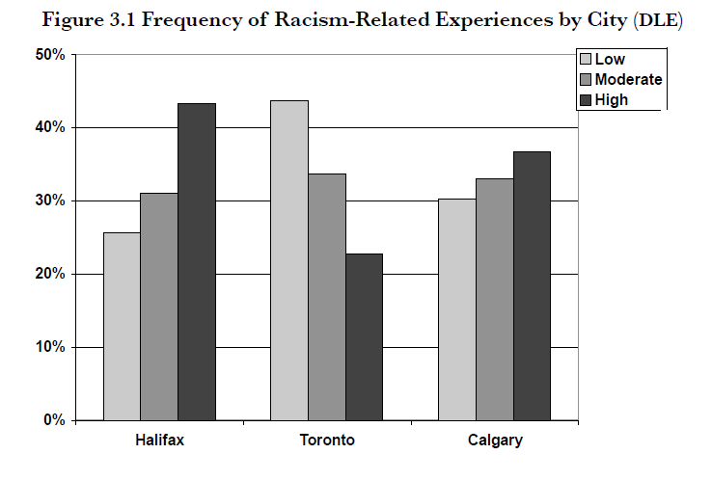
Figure 3.1 Frequency of Racism-Related Experiences by City (DLE)
BEGIN PRODUCER’S NOTE:
The following is estimated data from the bar graph “Frequency of Racism-Related Experiences by City”. Precise data points are not provided in the bar graph. The cities are Halifax, Toronto and Calgary. Each city has three levels of Racism-Related Experiences. The levels are in order as follows; low, moderate and high and range from 0-50%.
END PRODUCER’S NOTE.
BEGIN GRAPH:
BEGIN DATA:
Halifax
Low: 27%
Moderate: 32%
High: 44%
Toronto
Low: 44%
Moderate: 34%
High: 23%
Calgary
Low: 30%
Moderate: 33%
High: 37%
END DATA.
END GRAPH.
END FIGURE 3.1.

Example 4.1.B: Placement of Caption for Visual Media
Consider the following example, excerpted from Phillips et al. (2002).
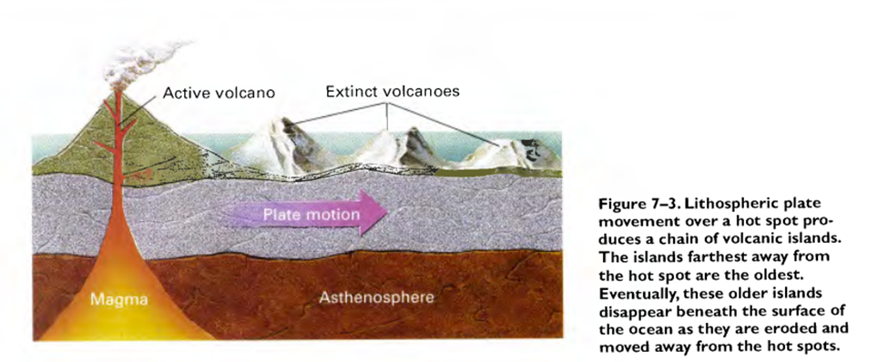
In the e-Text, the visual media may be retained with the caption nested within the accompanying Figure tag.
BEGIN FIGURE 7.3:
BEGIN PRODUCER’S NOTE:
Refer to tactile supplement (print page 119).
END PRODUCER’S NOTE.
BEGIN CAPTION:
Figure 7-3. Lithospheric plate movement over a hot spot pro­duces a chain of volcanic islands. The islands farthest away from the hot spot are the oldest. Eventually, these older islands disappear beneath the surface of the ocean as they are eroded and moved away from the hot spots.
END CAPTION.
END FIGURE 7.3.

Example 4.1.C: Use of Specific Visual Media Tags
Consider the following example, excerpted from Oliver (2021).
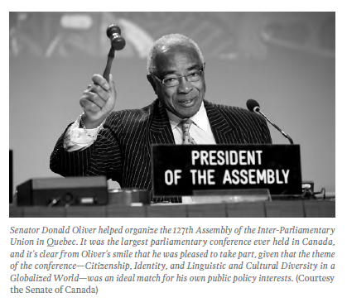
In the e-Text, there is an alt-text description added to the visual media that sufficiently describes its content so there is no Producer’s Note included in the Figure tag.
BEGIN PHOTOGRAPH:
BEGIN CAPTION:
Senator Donald Oliver helped organize the 127th Assembly of the Inter-Parliamentary Union in Quebec. It was the largest parliamentary conference ever held in Canada, and it’s clear from Oliver’s smile that he was pleased to take part, given that the theme of the conference—Citizenship, Identity, and Linguistic and Cultural Diversity in a Globalized world—was an ideal match for his own public policy interests.
END CAPTION.
BEGIN SOURCE:
Courtesy the Senate of Canada
END SOURCE.
END PHOTOGRAPH.

4.2 Cartoons
This section refers to short cartoons and/or comic strips in the original print and how these cartoons should be represented in the e-Text. For graphic novels and comic books, refer to guidance from The Accessible Comics Collective and NNELS - Comic Book/Graphic Novel Description: Introduction.
- For cartoons in the original print, each frame is numbered in the e-Text within BEGIN/END CARTOON tags. The frame numbering follows the format XX of XX and is enclosed by square brackets. Example 4.2.A demonstrates proper formatting.
- For more detailed guidance on authoring descriptions of cartoons, refer to Comic Book/Graphic Novel Description: Introduction from NNELS.

Example 4.2.A: Cartoon Strip
BEGIN CARTOON:
GARFIELD
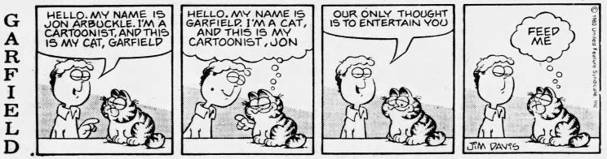
BEGIN PRODUCER'S NOTE:
[Frame 1 of 4] Man and cat. The man speaks to the reader and points to the cat.
END PRODUCER'S NOTE.
HELLO, MY NAME IS JON ARBUCKLE. I’M A CARTOONIST, AND THIS IS MY CAT, GARFIELD
BEGIN PRODUCER'S NOTE:
[Frame 2 of 4] Jon and Garfield. Garfield points to Jon and thinks aloud in a thought bubble.
END PRODUCER'S NOTE.
HELLO, MY NAME IS GARFIELD. I’M A CAT, AND THIS IS MY CARTOONIST, JON
BEGIN PRODUCER'S NOTE:
[Frame 3 of 4] Jon and Garfield. Jon speaks to the reader.
END PRODUCER'S NOTE.
OUR ONLY THOUGHT IS TO ENTERTAIN YOU
BEGIN PRODUCER'S NOTE:
[Frame 4 of 4] Jon and Garfield. Garfield thinks aloud in a thought bubble.
END PRODUCER'S NOTE.
FEED ME
BEGIN SOURCE:
JIM DAVIS
©1983 United Feature Syndicate, Inc.
END SOURCE.
END CARTOON.

4.3 Icons and Emojis
This section contains guidance on small images in texts, such as emojis, icons, or wayfinding symbols.
- Emojis have set names listed in Unicode which are announced by screen reading software. The emoji should be placed in the e-Text.
  - For the producer’s reference, descriptions or interpretations can be found in Emojipedia or Unicode.
- Purely decorative icons or symbols may be omitted without explanation, if the producer determines they do not have any meaning to the text nor serve any wayfinding function. For example, in a child’s novel where lightning bolt symbols are located at the end of many paragraphs but are not referred to or explained anywhere in the book.
- Wayfinding symbols are common in textbooks and can be explained in the General Producer’s Note at the start of the e-Text. For example, a business textbook with a lightbulb icon which is explained in the front matter as indicating New Idea content. It is up to the producer’s discretion as to which of the following approaches are used in the e-Text:
  - The wayfinding symbol may be retained in the e-Text as an image, and must have alternative text that indicates the purpose of the image (e.g., “NEW IDEA icon”), or
  - The wayfinding symbol may be replaced by an in-line indicator that communicates the purpose of the symbol (e.g., [NEW IDEA]). If these symbols occur more than once in the document, an explanation for this substitution must be provided in the General Producer’s Note.

4.4 Tactile Supplements
If a tactile graphic is determined to be an effective means of representing visual media, the tactile graphic is produced and provided to the reader in a supplemental volume.
- Tactile graphics are indicated using a Producer’s Note that refers the reader to the correct print page in the tactile supplement. An image description in a Producer’s Note should also be provided in the e-Text. This image description is provided for readers that do not have access to the corresponding tactile supplement or do not use tactile graphics.
  - Refer to Example 4.4.A: Producer’s Note Referring to a Tactile Supplement.
- The e-Text should refer to pages within the tactile supplement. If page numbers are not available, the producer should provide references that most easily direct the reader to the correct graphic in the tactile supplement.
  - It is incumbent on the current producer to adjust these references in the e-Text to match tactile supplement page numbers once this supplement is available.

Example 4.4.A: Producer’s Note Referring to a Tactile Supplement
BEGIN FIGURE:
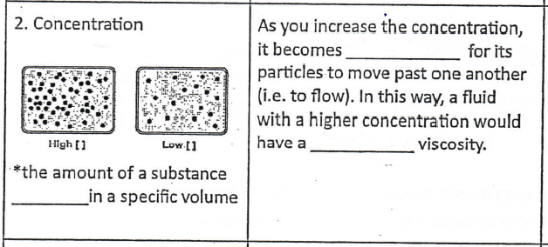
2. Concentration
BEGIN PRODUCER'S NOTE:
Refer to tactile supplement (Print Page a12) for figure.
END PRODUCER'S NOTE.
*the amount of a substance [BLANK SPACE] in a specific volume
As you increase the concentration, it becomes [BLANK SPACE] for its particles to move past one another (i.e. to flow). In this way, a fluid with a higher concentration would have a [BLANK SPACE] viscosity.
END FIGURE.

5.0 Punctuation and Special Characters
This section outlines how to properly format punctuation and special characters in e-Texts.
- The original print should be reproduced as printed, but there may be exceptions to prioritize accessibility and the internal consistency of a particular e-Text.
  - For example, when a non-standard shape (e.g. ⛋) denotes bullet points in an unordered list, these are replaced with standard bullet options in an unordered list in Word. This is to ensure that the list is correctly announced by reading apps or screen reading software.
- Any character not on the standard English keyboard must be entered using Alt codes (e.g. alt+130 for é) or the Insert Symbol menu in Word.
  - Refer to 10.4.1 Alt Codes to Enter Special Characters for links to web-based lists of Alt code keyboard shortcuts. If there is some ambiguity over the use of the symbol in context and how it will be read, consider testing how the symbol will be announced by the reading app or software.
  - If there is no ASCII/Unicode character for a special character present in the original print, it must be replaced by its name contained within square brackets. The name of a symbol may require research to identify its correct identity and function in the context of the material.

5.1 Non-English Characters
For guidance on the use of longer passages in languages other than English within English language materials, refer to 8.2 Multiple Languages within the Same Document/File.
- Non-English words or characters should be coded correctly by language in Word (e.g. English (Canada), Vietnamese).
- The producer should use their discretion on how to treat words and phrases in other languages that are positioned within an English sentence.
  - For example, consider the sentence: “The handwritten sign in the window of the corner store read “Ouvert (pour le moment).” In this sentence, the language of “Ouvert (pour le moment)” is marked as French (Canada).
- In addition to being coded in the correct language, the correct characters should be used, especially if the OCR incorrectly identifies it as another character with a similar shape. These can be entered with Alt codes or from the Insert Symbol menu.
- Agencies should make reasonable effort to ensure the accuracy of content in language(s) which are unfamiliar to the producer.

5.2 Quotation Marks
- Double or single ‘smart’ (curved) quotation marks or straight quotation marks may be used in the e-Text.
- Do not use a backtick (`) as a single quotation mark.

5.3 Hyphens and Dashes
- Hyphens may be typed normally with the keyboard.
  - Retain hyphens as appropriate in hyphenated words (e.g. merry-go-round) but remove them when they are being used at the end of a line in print (e.g. wast- -ed).
  - Styled lists must be used instead of hyphens for lists, even if they resemble hyphens in the original print. For more information, refer to 7.2 Lists.
  - For the use of hyphens in fill-in-the-blank situations, refer to 8.4 Workbooks, Worktexts.
  - For the use of a hyphen as a minus symbol, refer to 8.6 Mathematical/Technical Content.
- Insert an en-dash using the Symbols list or the Alt code (refer to 10.4.1: Alt Codes to Enter Special Characters). The en dash is used to indicate a span (e.g. January 4–16, 2019).
- Insert an em-dash using the Symbols list in Word or the Alt code (refer to 10.4.1: Alt Codes to Enter Special Characters). The em dash is used to create a strong break in the structure of a sentence (e.g. "Smell those pies—especially the blueberry one!").
  - Do not represent an em-dash with two hyphens. However, if it is presented that way in the original print, the producer should use their discretion as to how the em-dash is entered in the e-Text.

5.4 Ellipsis
- The Unicode ellipsis character (…) should be used instead of three periods (...). Word will automatically insert this character if Auto-formatting is enabled.
  - Separate ellipses from preceding and following words with spaces.
  - Do not separate ellipses from punctuation that follows. The producer should use their discretion when determining the separation between an ellipsis and a period.
- Ellipses must be used in the space between titles and page numbers in the table of contents. For more information, refer to 2.4 Table of Contents - Original Print.

5.5 Numbers
- Arabic numerals (1, 2, 3 etc.) can be typed using the keyboard or number pad unless they are part of math content or expressions, in which case refer to 8.6 Mathematical/Technical Content.
- Roman numerals are retained in their alphabetic form (e.g. iv) whether they are within the text or used in pagination.
  - Roman numerals can be in lower or upper case, following how they are presented in print.
  - For Roman numerals in math content (MathML), refer to 8.6 Mathematical/Technical Content.
- When including large numbers in plain text (not MathML), spaces would cause each group of digits to read as an individual number.
  - If the number is formatted with spaces between groups of three digits in the original print, remove the spaces in e-Text (e.g. 1 000 000 becomes 1000000).
  - If the number is formatted with commas between groups of three digits in the original print, retain the commas in e-Text (e.g. 1,000,000 remains 1,000,000).
  - For numbers written in English and French, commas and spaces have different meanings:
    - In English, a comma separates groups of three digits and a period is used as the decimal marker.
  - In French, a space separates groups of three digits and a comma is used as the decimal marker.

6.0 Page Layout
The sections that follow provide specific guidance for layout elements in e-Text.

6.1 Indentation
- Indentation is used for many purposes in text. Use the tags BEGIN/END INDENT to indicate a block or paragraph of indented text in the original print.
  - When indented text is best characterized as another text element (e.g. block quotes, letters), a type-specific tag must be used to mark the beginning and end. For examples, refer to 10.3: Commonly Used Tags and Indicators in e-Text.
- When nested levels of indentation are informative, the BEGIN/END INDENT tags should be labelled to reflect these levels (e.g. BEGIN INDENT 1). Refer to Example 6.1.A: Code with Indentation Levels.

Example 6.1.A: Code with Indentation Levels
Consider the following excerpt, written in Python:
def process_data(data):
for item in data:
if isinstance(item,dict):
print(“Processing dictionary:”)
for key, value in item. items():
Since the indentation communicates nesting, these must be reflected in the e-Text:

BEGIN INDENT 1:
def process_data(data):
BEGIN INDENT 2:
for item in data:
BEGIN INDENT 3:
if isinstance(item,dict):
BEGIN INDENT 4:
print(“Processing dictionary:”)
for key, value in item. items():
END INDENT 4.
END INDENT 3.
END INDENT 2.
END INDENT 1.

6.2 Text Boxes
- If a text box in the original print is in-line with the text and does not interrupt or act separately from the text, the text box is ignored and not tagged.
- Use the tags BEGIN/END TEXT BOX to indicate content in a text box in the original print which interrupts the flow of the main text or is otherwise set apart.
- Other elements inside text boxes in the original print, such as figure descriptions or footnotes, must also be kept inside the TEXT BOX tags.

Example 6.2.A: Text Box Interrupting Flow of Main Text
Consider the following three pages, excerpted from Mader and Windelspecht (2014). Please note that some content contained in the text box has been removed for brevity in the example e-Text. In an e-Text production the entire contents of the text box must be included.
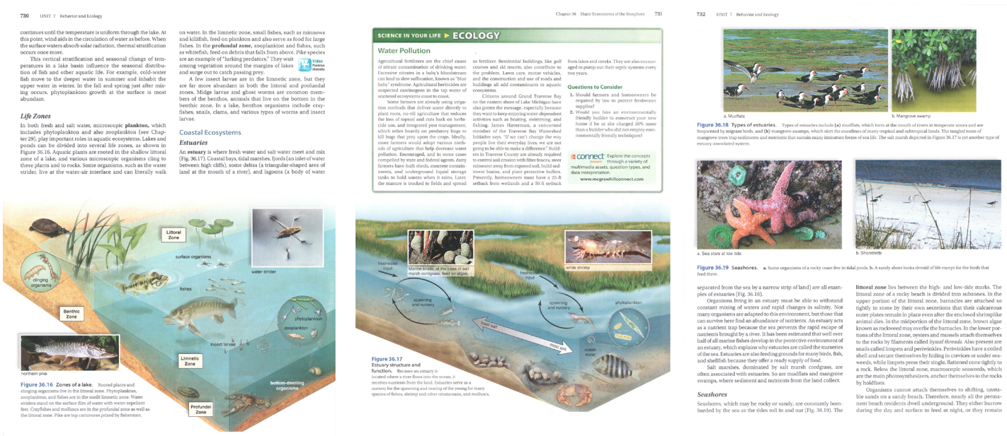
In the e-Text, the text box may be placed where it interrupts the flow of the main text paragraph. This interruption must be indicated with the appropriate Producer’s Notes.
Estuaries
An estuary is where fresh water and salt water meet and mix (Fig. 36.17). Coastal bays, tidal marshes, fjords (an inlet of water between high cliffs), some deltas (a triangular-shaped area of land at the mouth of a river), and lagoons (a body of water
BEGIN PRODUCER’S NOTE:
Text continued on print page 732.
END PRODUCER’S NOTE.
PRINT PAGE 731
BEGIN FIGURE:
Figure 36.17 Estuary structure and function. Because an estuary is located where a river flows into the ocean, it receives nutrients from the land. Estuaries serve as a nursery for the spawning and rearing of the young for many species of fishes, shrimp and other crustaceans, and molluscs.
END FIGURE.
BEGIN BOXED MATERIAL:
SCIENCE IN YOUR LIFE
ECOLOGY
Water Pollution
Agricultural fertilizers are the chief cause of nitrate contamination of drinking water.
[…content omitted for brevity…]
They are also encouraged to pump out their septic systems every two years.
Questions to Consider
BEGIN LIST:
- Should farmers and homeowners be required by law to protect freshwater supplies?
- Would you hire an environmentally friendly builder to construct your new home if he or she charged 20% more than a builder who did not employ environmentally friendly techniques?
END LIST.
END BOXED MATERIAL.
BEGIN BOXED MATERIAL:
McGraw Hill connect
BIOLOGY
Explore the concepts through a variety of multimedia assets, question types, and data interpretation.
www.mcgrawhillconnect.com
END BOXED MATERIAL.
PRINT PAGE 732
BEGIN PRODUCER’S NOTE:
Text continued from print page 730.
END PRODUCER’S NOTE.
separated from the sea by a narrow strip of land) are all examples of estuaries (Fig. 36.18).

6.3 Sidebars
- Use the tags BEGIN/END SIDEBAR for content that is presented as a sidebar in the original print.
- Sidebar content should be placed immediately following the text to which the sidebar content refers or following adjacent in-line text.

6.4 Definitions and Key Terms
- The producer should use their discretion as to placement of definitions/key terms that are not presented in-line with text.
  - For example, a producer should place sidebar definitions at the end of a paragraph whose content is relevant to the content of the sidebar as opposed to interrupting the flow of the paragraph with the sidebar.
- If the definitions are in-line with other text, tags are not needed.

7.0 Data Organization
The sections below provide specific guidance for elements that organize and display data in the e-Text.

7.1 Tables
- Tables in the e-Text must use the BEGIN/END TABLE tags.
- Tables should be inserted into the e-Text using the Insert Table function in Word. The required number of rows and columns are entered and then the table is auto-generated and inserted. Refer to Example 7.1.A: Complex Table Inserted using Table Function.
- Content in complex tables, such as those that include merged or split cells, cannot be easily navigated with keyboard controls or read using screen reading software. For these tables, the producer should use their discretion as to how they are represented in the e-Text. Any changes made to the table from its original layout should be noted in a Producer’s Note.
  - Nested or split cells may be merged and re-labelled, and the table inserted using the Insert Table function in Word. Example 7.1.A: Complex Table Inserted using Table Function, OR
  - Data may be entered as text, using the BEGIN/END DATA tags. For more information refer to Example 7.1.B: Complex Table Inserted as Text.
- Use the tags BEGIN/END KEY in somewhat rare cases when tables or charts have complex columns or rows that need to be summarized or abbreviated to reduce needless repetition of information. For more information refer to Example 7.1.B: Complex Table Inserted as Text.
- If information on the source of the data in the table is provided in the original print, insert source information into the e-Text using SOURCE tags. Place source information relative to the table according to how it is presented in the original print. For more information refer to Example 7.1.A: Complex Table Inserted using Table Function.
- When tables in the original print contain blank cells, the producer must note these using the [BLANK CELL] cell indicator. If the occurrence of blank cells is limited in the original print, this should be indicated to the reader using a Producer’s Note within the TABLE tags. If blank cells occur frequently in tables within the original print, the use of the blank cell indicator should be detailed in the PGN.

Example 7.1.A: Complex Table Inserted using Table Function
Table 2.4 is excerpted from James (2010). The columns are labelled with merged cells.
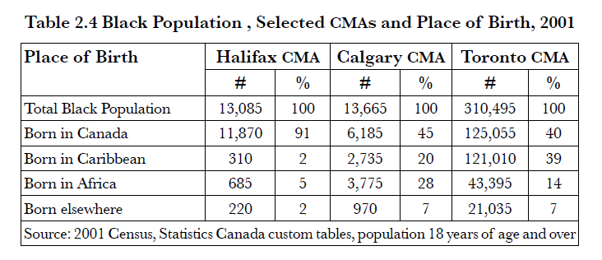
However, these must be separated and relabelled so that the table inserted in Word is more accessible to users of screen reading software.
BEGIN TABLE 2.4:
Table 2.4 Black Population, Selected CMAs and Place of Birth, 2001
Place of Birth | Halifax CMA # | Halifax CMA % | Calgary CMA # | Calgary  CMA % | Toronto CMA # | Toronto CMA %
Total Black Population | 13,085 | 100 | 13,665 | 100 | 310,495 | 100
Born in Canada | 11,870 | 91 | 6,185 | 45 | 125,055 | 40
Born in Caribbean | 310 | 2 | 2,735 | 20 | 121,010 | 39
Born in Africa | 685 | 5 | 3,775 | 28 | 43,395 | 14
Born elsewhere | 220 | 2 | 970 | 7 | 21,035 | 7
BEGIN SOURCE:
Source: 2001 Census, Statistics Canada custom tables, population 18 years of age and over
END SOURCE.
END TABLE 2.4.

Example 7.1.B: Complex Table Inserted as Text
Tableau 11.1 is excerpted from Ollivier (1999). Note the complex nested data contained in individual cells.
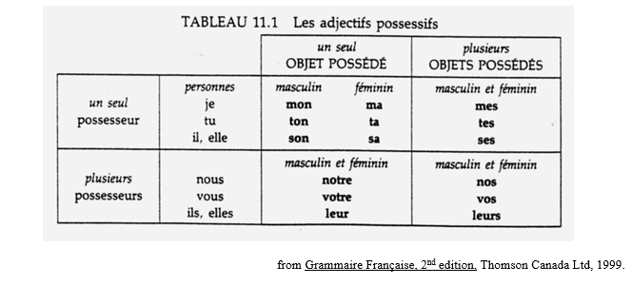
Rather than adapting and inserting this complex table using the Insert Table function in Word, the producer may opt to insert this table as text using DATA and KEY tags, as below.
BEGIN TABLE:
TABLEAU 11.1 Les adjectifs possessifs
BEGIN PRODUCER’S NOTE:
The table in the original print includes merged cells. The table data is provided in-line and a key is added to improve access for the user of screen reader software.
END PRODUCER’S NOTE.
BEGIN KEY:
OPM: un seul OBJECT POSSÉDÉ, masculin
OPF: un seul OBJECT POSSÉDÉ, féminin
POPMF: plusieurs OBJECT POSSÉDÉS, masculin et féminin
END KEY.
BEGIN DATA:
un seul possesseur
personnes: je
OPM: mon
OPF: ma
POPMF: mes
un seul possesseur
personnes: tu
OPM: ton
OPF: ta
POPMF: tes
un seul possesseur
personnes: il, elle
OPM: son
OPF: sa
POPMF: ses
plusieurs possesseurs
personnes: nous
OPM: notre
OPF: notre
POPMF: nos
plusieurs possesseurs
personnes: vous
OPM: votre
OPF: votre
POPMF: vos
plusieurs possesseurs
personnes: ils, elles
OPM: leur
OPF: leur
POPMF: leurs
END DATA.
BEGIN SOURCE:
from Grammaire Française, 2nd edition, Thompson Canada Ltd. 1999.
END SOURCE.
END TABLE.

7.2 Lists
- All automatically formatted unordered bulleted lists should have solid black circles for top level list items regardless of the list indicators used in print. Avoid the use of custom symbols (e.g. ⛋), or images unless these are informative in the original text. If used, these custom symbols or images should be communicated to the reader in the PGN. Refer to 10.2 Producer’s General Notes Template and Conditional Statements.
- All lists in the e-Text must be contained by BEGIN/END LIST tags.
- Bullets in multi-level or nested lists should follow the default style in Word. For example:
  - Text
    - Text
      - text
- Automatic bulleted list and automatic numbered list options must be used to create all such lists in the e-Text.
  - Use the automatically applied list style in Word and make certain that indentation across list levels (e.g. nested lists) is consistent throughout the e-Text.
- For lists with no markers add solid bullets when applying the List style.
  - The producer must add a Producer’s Note indicating that they identified the content as a list in the original print and that markers were added. Screen reading software will not announce the content as a list if no markers are present and the producer has selected the “none” option in the Bullet Library in Word.
- For lists that are separated by headings, apply the appropriate heading style and separate the list using hard returns around the styled heading. Refer to Example 7.2.A: Lists Separated by Headings.
- For lists separated between pages in the original print, insert the appropriate print page number in the e-Text with a PRINT PAGE tag in between the list entries as per the original print. Use soft returns so the list does not become two lists. For example:
- Text¶
- Text↵
PRINT PAGE XX¶
- Text¶
- Text¶

Example 7.2.A: Lists Separated by Headings
Consider the following list, excerpted from Sandner (2016).
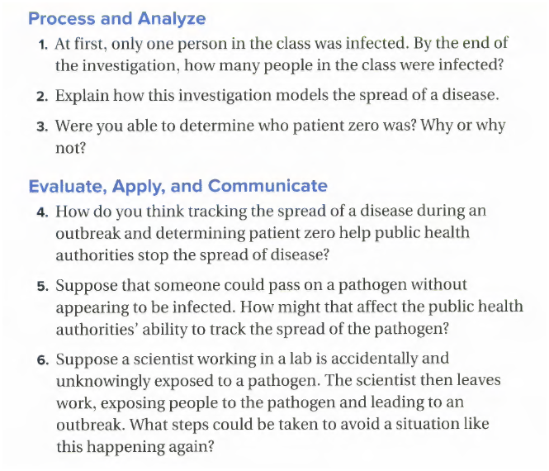
In the e-Text, the appropriate headings must be retained with hard returns used to ensure heading styles are not applied to list items:
BEGIN LIST:¶
Process and Analyze¶ [Note this text would have a heading style applied that is consistent with the rest of the e-Text]
- At first, only one person in the class was infected. By the end of the investigation, how many people in the class were infected?¶
- Explain how this investigation models the spread of a disease.¶
- Were you able to determine who patient zero was? Why or why not?¶
Evaluate, Apply, and Communicate¶ [Note this text would have a heading style applied that is consistent with the rest of the e-Text]
- How do you think tracking the spread of a disease during an outbreak and determining patient zero help public health authorities stop the spread of disease?¶
- Suppose that someone could pass on a pathogen without appearing to be infected. How might that affect the public health authorities' ability to track the spread of the pathogen?¶
- Suppose a scientist working in a lab is accidentally and unknowingly exposed to a pathogen. The scientist then leaves work, exposing people to the pathogen and leading to an outbreak. What steps could be taken to avoid a situation like this happening again?¶
END LIST.¶

8.0 Content-Specific Guidelines
The sections below provide guidance for formatting specific content in the e-Text.

8.1 Annotations
- Annotations are relatively rare and are mostly used in grammar or writing guides.
- Use BEGIN/END ANNOTATION tags to surround annotation text.
- Annotations are to be placed after the paragraph they are annotating, but they can be grouped together at the end of a longer passage (e.g. a sample essay) at the discretion of the producer.
- Annotations can be inserted into a paragraph if they are referring to a very specific part of the text, or if it would be confusing to the reader if the annotation were far removed from its referent. The annotation should be inserted where it will be least disruptive to the flow of the text.

8.2 Multiple Languages within the Same Document/File
- Prior to scanning the hard copy original, ensure that the OCR program is set to include all languages present in the original print. The producer should review the resulting scanned file to ensure that the multiple languages were correctly identified.
- Language should be coded correctly in Word.
  - Per 1.4 General Document Formatting, the producer should ensure that “Detect language automatically” is unselected in the Language settings for the file.
  - Configure the language Word is using for Editing and Authoring, using the language of the original print.
- It is at the producer's discretion as to how single words in a language other than the main document language are coded in the e-Text.
  - To switch languages for only specific content, highlight/select the content and follow the instructions above for configuring the editing/authoring language in Word.
- Agencies should make reasonable effort to ensure the accuracy of content in language(s) that are unfamiliar to the producer.
- Agencies may opt to provide a disclaimer regarding language accuracy where a producer fluent in that language was not available.

8.3 Superscript and Subscript
- If the superscript or subscript is used in a literary context, use the superscript or subscript font modifier in Word. The auto-formatting function for ordinal numbers in Word (e.g. 1st, 2nd, 3rd) should be used.
- Use the Equation editor in Word for any math/technical content that includes superscripts or subscripts. Refer to 8.6 Mathematical/Technical Content for more information on inserting math expressions into e-Text.

8.4 Workbooks, Worktexts
- To indicate a small space left to write in one word or short answers, use [BLANK SPACE]. Square brackets are used to differentiate from adjacent content in the original print contained in parentheses.
- To indicate a multiple line space for longer answers, use [BLANK SPACE, # LINES], including the number of blank lines.
- Alternatively, four hyphens in parentheses can be used to indicate a one line blank space (----), or the number of blank lines followed by four hyphens in parentheses to indicate multiple line spaces (3 ----). This notation is at the discretion of the producer or agency. If used, the meaning of the hyphens must be included in the PGN.

8.5 Poetry Content
- Poems present within the original text must be indicated using BEGIN/END POEM tags.
  - If most of the original print consists of poetry (e.g. a book of poems), the PGN should contain information that prompts the reader to adjust the verbosity settings of their screen reading software to announce punctuation and spaces.
- Poetry is an artistic medium that often uses specific visual formatting to convey a message or to indicate how it should be read.
  - Poetry, prose, and other text whose line formatting must be reproduced exactly as in the original print may use a soft return at the end of each line, and a hard return at the end of each stanza. This formatting of the poem should be communicated to the reader in the PGN or a Producer’s Note, so they could adjust the settings of the reading system accordingly.
  - Maintain blank lines and extra spaces between lines, words, or characters if they denote meaning in the original print. Refer to Example 8.5.A: Maintaining Spatial Formatting in Poetry.
  - A Producer's Note may be required when text/words follow unique spatial orientation (e.g. “shape poetry” such as a poem that is formatted into a triangle to resemble a tree).
- Line numbers in poetry, prose, and other text are on a line by themselves, followed by a soft return and precede the line to which they apply.
- If blank spaces are used in the original print to preserve the metre of the poem, the producer should insert tilde (~) for each foot (i.e. beat) not represented by text. The use of this symbol should be communicated to the reader through a Producer’s Note if use within the e-Text is infrequent. If use is frequent in the original print, note the use of the symbol in the PGN.
  - For example: Plays or poetry in iambic pentameter use four tildes ( ~~~~ ) to represent the missing meter.
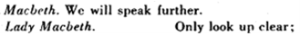
MACBETH: We will speak further.
LADY MACBETH: ~~~~ Only look up clear.
- For lines with further indentation, the producer must determine, based on context, if there is a missing meter in the poem or if the space is the result of spatial formatting that is intended to be informative to the reader.
  - If blank space(s) are informative to the reader, the producer should preserve the spatial formatting of the original print by counting (or approximating) these spaces and adding them to the e-Text. For more information refer to Example 8.5.A: Maintaining Spatial Formatting in Poetry.

Example 8.5.A: Maintaining Spatial Formatting in Poetry
Consider the following excerpt from The Waste Land by T.S. Eliot (2020):
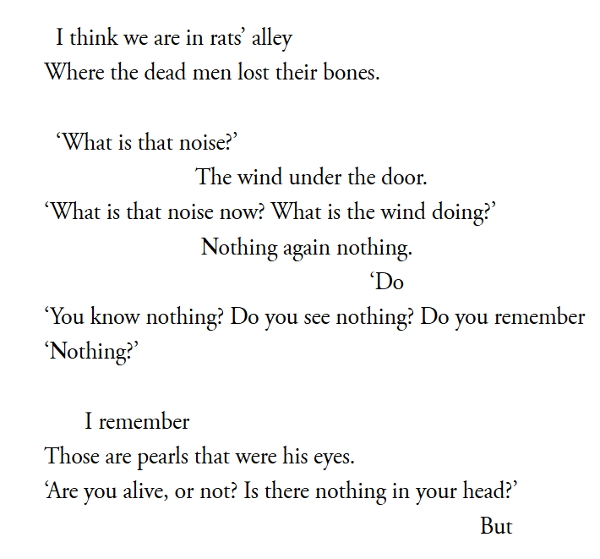
In the e-Text, the poem is indicated by tags. Hard and soft returns, as well as individual spaces, are used to preserve the spatial formatting for the reader.
BEGIN POEM:↵
I think we are in rats’ alley↵
Where the dead men lost their bones.¶
¶
‘What is that noise?’ ↵
The wind under the door. ↵
‘What is that noise now? What is the wind doing?’ ↵
Nothing again nothing. ↵
Do↵
‘You know nothing? Do you see nothing? Do you remember¶
‘Nothing?’¶
¶
I remember↵
Those are pearls that were his eyes.¶
‘Are you alive, or not? Is there nothing in your head?’¶
But↵
END POEM.

8.6 Mathematical/Technical Content
- In literary or non-technical contexts:
  - The producer should use their discretion as to whether entry via the equation editor is appropriate. For example: In “A park bench was spray painted with “J+S = Love,” it would not be appropriate, given the context, to encode this as mathematical content. Another common example is temperature notation used in literary contexts: “It was -30 Celsius outside today!”
- In mathematical and technical contexts:
  - Equations should be entered using the Word equation editor to ensure it can be read properly by assistive technologies, e.g. $E=mc^{2}$. For more software and tools for entering digital accessible math/technical content in e-Text, refer to 10.4.2 Useful Authoring Tools/Software.
    - Equation editor can be used to “Insert built-in equation” for commonly used content such as the Pythagorean theorem. Use “Write new equation” to manually enter content, and “Edit equations” to alter an equation that was previously entered.
- The content created by the equation editor can also be exported to MathML or LaTex if needed.
- Greek letters must be presented in the e-Text as they are in the original print, and in literary contexts should be added via the Symbols list or using Alt codes. In a math or technical context, enter Greek letters using the equation editor. For example, in statistics mu (μ) is the population mean or expected value.
  - Refer to 10.4.1 Alt Codes to Enter Special Characters for web-based lists of Alt codes for Windows and Option codes for macOS.

9.0 Notes

9.1 Footnotes/Endnotes
- Footnotes and endnotes are references to provide source information or further explanation that do not interrupt the flow of the text.
  - In the original print, footnotes and endnotes are indicated by a number or symbol in superscript, usually located at the end of a sentence. This directs the reader to a reference or explanatory text placed at the bottom of individual pages (footnotes) or the end of the chapter or entire text (endnotes).
- In the e-Text, the superscript number or symbol from the original print is preceded by a FOOTNOTE or ENDNOTE tag enclosed in square brackets in the same location as in the original print. Do not apply superscript formatting to the number or symbol in the FOOTNOTE or ENDNOTE indicator.
  - For footnotes, the corresponding reference or explanatory text is placed at the end of the paragraph, for the reasons not to include artificial breaks at the end of the page, and to keep the note indicator and the explanatory text be closer. Refer to Example 9.1.A: Footnotes.
  - For endnotes, location of the corresponding reference or explanatory text must:
    - replicate print when an entire book or document is produced, and when a book is split into individual sections and the endnotes are at the end of each section in print.
    - be moved to the end of their relevant section documents when books are split into individual sections and the endnotes are represented at the end of the book in print.
- If a footnote or endnote is indicated by a symbol rather than a number, that symbol should be inserted into the e-Text using Alt codes or from the Insert Symbol menu. Refer to 10.4.1 Alt Codes to Enter Special Characters.
  - For example, a superscript dagger (†) denoting an endnote would be replaced in the e-Text with [ENDNOTE †].
- When a footnote indicator is placed in the last paragraph of a page and the paragraph ends on the next page, the corresponding reference or explanatory text must still be placed at the end of the paragraph and a Producer’s Note is required and placed before the note.

Example 9.1.A: Footnotes
Consider the following excerpt from What's Next for Woman Suffrage? An Overview of the State of the Field (Marino, 2024, p.7). Footnote indicators are in-line superscript numbers. Footnote references in the original print are placed at the bottom of print page 7 and so have been omitted from the excerpt below.
“Notable among these early texts were Inez Haynes Irwin’s The Story of the Woman’s Party and Doris Stevens’ Jailed for Freedom, which celebrated major figures like Alice Paul and Lucy Burns who had become national leaders in the struggle for the federal amendment’s passage.⁵ Considering Irwin’s work, scholar Claire Delahaye argued that given Irwin’s background as a journalist and fiction writer, it is unclear how much of her work on the National Woman’s Party (NWP) is fact and how much is fiction. Delahaye comments on Irwin’s choice to use the word ‘Story’ in the title instead of ‘History’. She notes that in her account, Irwin ‘aims at chronicling the struggle for the vote while establishing the NWP as the only recognised suffrage group. Her work legitimises the NWP’s historic role while trying to appeal to future militants’.⁶”
Superscript indicators are replaced with footnote tags in the e-Text. Note that footnote references are inserted following the paragraph containing the corresponding footnote tags.
Notable among these early texts were Inez Haynes Irwin’s The Story of the Woman’s Party and Doris Stevens’ Jailed for Freedom, which celebrated major figures like Alice Paul and Lucy Burns who had become national leaders in the struggle for the federal amendment’s passage.[FOOTNOTE 5] Considering Irwin’s work, scholar Claire Delahaye argued that given Irwin’s background as a journalist and fiction writer, it is unclear how much of her work on the National Woman’s Party (NWP) is fact and how much is fiction. Delahaye comments on Irwin’s choice to use the word ‘Story’ in the title instead of ‘History’. She notes that in her account, Irwin ‘aims at chronicling the struggle for the vote while establishing the NWP as the only recognised suffrage group. Her work legitimises the NWP’s historic role while trying to appeal to future militants’. [FOOTNOTE 6]
BEGIN FOOTNOTES:
FOOTNOTE 5: Inez Haynes Gillmore, The Story of the Woman’s Party (New York, 1921); Doris Stevens, Jailed for Freedom (New York, 1920).
FOOTNOTE 6: Claire Delahaye, ‘Deconstructing and reconstructing woman suffrage history: The Story of the Woman’s Party’, American Studies Journal 68 (2019), May 28, 2024
END FOOTNOTES.

10.0 Templates and Resources
Sections 10.1 and 10.2 contain templated content. If copying and pasting content from these sections, the content enclosed in square brackets must be updated to reflect the current e-Text.

10.1 Producer’s Title Page Template
[BOOK TITLE (in uppercase)]
Subtitle: [XX]
Series: [Series name]
Grade: [Graded level]
Written by: [XX (format as indicated on print title page)]
Edited by: [XX (format as indicated on print title page)]
Translated by: [XX (format as indicated on print title page)]
Published by: [XX]
[Location of Publisher]
[Copyright information]
ISBN-13: [xxxxxxxxxxxxx], ISBN-10: [xxxxxxxxxx]
Total number of print pages: [XX (all numbered pages in original print)]
e-Text produced by [XX (Agency name)]
[Year produced]
[City, Province]
File [XX] of [XX (In the case of partial production, this information should be updated across all Producer’s title pages in existing files as new files are produced and added to the sum of e-Text files produced for the title/work)]
Print page [XX] to [XX (pages ranges contained in current file)]

10.2 Producer's General Notes Template and Conditional Statements
This section provides standard, conditional, and content-specific statements for the PGN. The standard template PGN in Section 10.2.1 is required for all e-Texts produced using this style sheet. One of the two statements in Section 10.2.2 is required, depending on the agency decision regarding the retention or omission of non-decorative visual media. The statements in Section 10.2.3 are content-specific and should only be included in the PGN as required.
Please note: There is a field in the template below that the producer must update according to the e-Text. This field is indicated by [XX].

10.2.1 Standard Producer's General Notes Template
BEGIN PRODUCER'S GENERAL NOTES:
This e-Text has been produced with high fidelity to the original work. Typographical errors in the original work are maintained in the interest of fidelity in representation
When content and formatting that are not present in the original print are added by the producer, this is noted either with a Producer’s Note or an indicator enclosed in square brackets where it occurs in the e-Text.
The agency that produced and/or shared this e-Text does not have any control over and does not assume any responsibility for author or third-party websites or their content hyperlinked in the original print and transferred to the e-Text.
This e-Text allows the reader to navigate using headings. Headings can be accessed using the Outline view mode or Navigation Pane in Word. This document has [XX] levels of headings.
In Word for Windows: Press CONTROL-ALT-O for the Outline view. Press ALT-SHIFT-1 to browse headings of level 1, ALT-SHIFT-2 to browse headings of level 1 and 2 etc. Press ALT-SHIFT-A to expand the view to the entire text. In Word for macOS, navigate to the View ribbon and select “Outline” for the Outline View.
From the View ribbon in Word check the box to activate the Navigation Pane (or press CTRL-F or COMMAND-F and select the Headings tab). Select the heading to move to that content.
Page numbers from the print have been retained and have been prefixed with the words "PRINT PAGE" in caps. To locate page 35, for example, use CTRL-F to search for "PRINT PAGE 35". Print page numbers reflect the original source and will not be the same as the page numbering of the e-Text.
If this e-Text is altered in any way, the Word-generated Table of Contents will not automatically update. If changes are made (such as increasing font size), update the Word-generated Table of Contents by right-clicking anywhere within the Word-generated Table of Contents and clicking “Update Table of Contents” to ensure accurate navigation.
END PRODUCER'S GENERAL NOTES.

10.2.2 Conditional Statements for Producer’s General Notes
One of the following statements must be added to the PGN depending on how the agency treats non-text content in e-Text production.
If non-text content is retained in the e-Text:
All non-decorative visual elements from the original print have been maintained in this e-Text with alternative text descriptions and/or tactile graphic supplements provided for the reader’s reference.
If non-text content is replaced with text-based alternatives:
All visual elements from the original print have been removed in this e-Text. Non-decorative visual elements have been replaced with text-based alternatives.

10.2.3 Content-Specific Statements for Producer’s General Notes
Statements in this section may be required in the PGN to explain decisions made in the course of e-Text production.
- Context breaks
  - Context breaks in the narrative, which in the original print are represented as a [XX], are represented in this e-Text by three spaced asterisks: * * *.
- Segmented/metric numbers.
  - Where metric numbers are printed with spaces, commas have been inserted in e-Text.
- Spanish
  - When Spanish occurs in the text, text is italicized and Spanish punctuation is used. For example, "¡Olé!", "¿Cómo"
- Sidebars
  - The sidebars that duplicate text have been omitted.
- Missing meter in poetry
  - For plays or poetry in iambic pentameter, four tildes ( ~~~~ ) are used to represent missing meters.
- Tactile supplement
  - In the tactile supplement, only print page numbers are shown (21, a21, b21, c21, etc.).
  - On maps in the tactile supplement, unless otherwise instructed, the top of the page is always north.
- Wayfinding symbols
  - A purple diamond symbol used throughout the original print to indicate a fun fact has been replaced in this e-Text with [FUN FACT].

10.3 Commonly Used Tags and Indicators in e-Text
Tags:
BEGIN PRODUCER’S NOTE:
END PRODUCER’S NOTE.
BEGIN PRODUCER'S GENERAL NOTES:
END PRODUCER’S GENERAL NOTES.
BEGIN TABLE OF CONTENTS:
END TABLE OF CONTENTS.
BEGIN DEDICATION:
END DEDICATION.
BEGIN ACKNOWLEDGEMENTS:
END ACKNOWLEDGEMENTS.
BEGIN NOTE(S):
END NOTE(S).
BEGIN EXCERPT:
END EXCERPT.
BEGIN DEFINITION:
END DEFINITION.
BEGIN FIGURE:
END FIGURE:
BEGIN CAPTION:
END CAPTION.
BEGIN IMAGE:
END IMAGE.
BEGIN PHOTOGRAPH:
END PHOTOGRAPH.
BEGIN ILLUSTRATION:
END ILLUSTRATION.
BEGIN MAP:
END MAP.
BEGIN FLOWCHART:
END FLOWCHART.
BEGIN DIAGRAM:
END DIAGRAM.
BEGIN INFOGRAPHIC:
END INFOGRAPHIC.
BEGIN CARTOON:
END CARTOON.
BEGIN KEY:
END KEY
BEGIN INDENT:
END INDENT.
BEGIN QUOTE:
END QUOTE.
BEGIN LETTER:
END LETTER.
BEGIN POEM:
END POEM.
BEGIN LIST:
END LIST
BEGIN TEXT BOX:
END TEXT BOX.
BEGIN BOXED MATERIAL:
END BOXED MATERIAL.
BEGIN DISPLAYED MATERIAL:
END DISPLAYED MATERIAL.
BEGIN SIDEBAR:
END SIDEBAR.
BEGIN TABLE:
END TABLE.
BEGIN ANNOTATION:
END ANNOTATION.
BEGIN BACK COVER:
Only include the text (book summary etc.) and omit everything else (ISBN, price, website etc.)
END BACK COVER.
Indicators:
PRINT PAGE #
BLANK PAGE
[FOOTNOTE #]
[ENDNOTE #]
[BLANK SPACE]
[BLANK SPACE, # LINES]
[BLANK CELL]
[FRAME X OF Y]
END OF FILE

10.4 Producer Resources
Resources outlined and linked to in this section are provided for the producer’s reference only. This section is updated with each successive version of this style sheet.

10.4.1 Alt Codes to Enter Special Characters
For producers working in a Windows environment, consult one or more of the following web-based resources for a listing of the Alt codes to enter characters in Word.
- Alt Codes for Windows - simbl.cc
- Inputting Foreign Characters - LSU (language-specific)
For producers working in a macOS environment, consult one or more of the following web-based resources for a listing of the Alt codes to enter characters in Word. These codes are entered using the Option key.
- Symbol Codes: Macintosh Accent Codes - PSU.edu
- How to Type Special Characters on a Mac Keyboard - Mackeeper

10.4.2 Useful Authoring Tools/Software
Some examples of different math authoring or editing tools/software that can be used to extract or edit math content, or other related tools/software that may be useful in e-Text production include:
- Microsoft Equation Editor: for simple math editing in Word
- MathType: for professional and advanced formatting and editing
- MathCAT: for accessibility and screen reader support
- MathPix: for recognizing text and extracting math from images and PDFs
- InftyReader: for recognizing math-heavy documents and not for general text OCR
- OmniPage: for general OCR of mainly text-based documents
- ABBYY FindReader: for general OCR of text-based documents and documents with some math
The following is a summary of these tools:
Tool | Description | Best For | Cost | Work with
Equation Editor (Word) | Built-in tool in Microsoft Word for inserting mathematical symbols and expressions. | Simple equation editing in Word documents. | Free (included in Microsoft Word) | Built into Microsoft Word
MathType | Advanced equation editor with better formatting and compatibility across platforms. | Academic writing, editing, and publishing of math. | $81/year (Windows & Mac) $54/year (Google Docs Add-on) | Standalone software, and add-on for Word, Google Docs, and other tools
MathCAT | Accessibility-focused tool that supports screen readers and MathML. | Making math accessible for visually impaired users, not for editing math | Free & Open Source | NVDA add-on; integrated into JAWS 2024 as an open source library
MathPix | AI-powered OCR tool for extracting math from images and PDFs | Converting handwritten/scanned math to digital formats. | Free (10 conversions/month) $6.75/month (100 conversions) $13.5/month (unlimited conversions) | Standalone desktop and web application
InftyReader | Highly specialized math OCR tool designed to recognize complex mathematical formulas. | Converting scanned documents with complex and handwritten math into editable digital formats | $243 (personal)  $1215 (full license) | Standalone math-focused OCR software
OmniPage | General OCR software that can convert scanned image into editable text. | Converting scanned documents with some math recognition. | Starts at $213 one-time purchase | Standalone OCR software
ABBYY FineReader | General high-accuracy OCR tool that can convert scanned document into editable text | Converting PDFs and scanned documents with some math to editable formats. | Standard: $135/year Corporate: $225/year  One-time purchase: $285 (Standard), $427 (Corporate) | Standalone OCR software

10.2.4: Working with text styles in Word
- When the built-in text styles in Word are used to format headings and other emphasized text, it creates a navigational structure that enables readers to easily move through the e-Text.
- These text styles, such as Heading 2 or Emphasis, are announced by screen reading software, and provide information that may be only visually accessible in the original.
- Producers may customize the appearance of the existing built-in styles, or create new styles if desired.
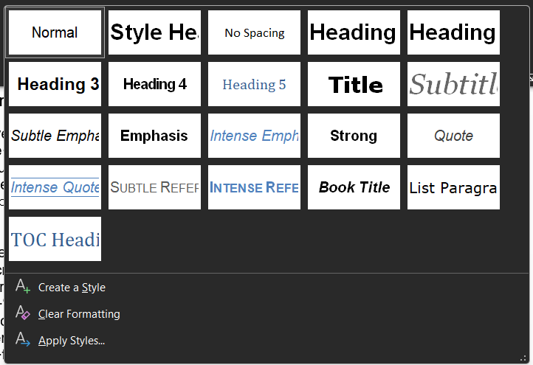

10.5 Glossary
This Glossary provides working definitions of terms specific to e-Text production as used throughout this style sheet.
A context break occurs when the topic being discussed or perspective of a narrative changes without a heading. It is sometimes indicated by a symbol or series of symbols.
Decorative visual elements are present solely for visual impact and convey no information to the reader.
e-Text is a Word document that uses tags, indicators, producer’s notes and other conventions to communicate the text-based content, layout, and non-text content of an original print item to a reader.
A hard return (or paragraph break) occurs when the Return or Enter Key is pressed. This begins a new paragraph.
In-line with text indicates the content is presented within the overall flow of the main text, rather than being placed elsewhere on the page, such as along the side or in a header or footer.
Machine-readable text refers to text content that is selectable, searchable, and is recognized and read by text-to-speech software. It is entered directly in the document, as opposed to images of text, which are pixel-based representations of text and, as such, are not machine-readable.
Non-Decorative visual elements contain information for the reader. This information needs to be communicated to the reader either with alt-text or a producer’s note.
Non-Text Content is any element that is not displayed as machine-readable text. It can range from complex visual elements like charts, graphs, photographs, or drawings to simple icons or emojis.
Pagination refers to denoting the page numbers of the original print using print page indicators, for example PRINT PAGE 12. Due to the reformatting of an e-Text, the page numbers of the original print are not necessarily the same as those of the Word document. Print page number indicators always precede the page content of the original print .
A soft return (or line break) occurs when the Shift and Enter Keys are pressed simultaneously. This begins a new line.
A Tactile Graphic communicates the information in a visual element, such as a diagram, a chart, or a map, using raised lines, textured surfaces, and braille labels. It is printed from a digital file onto specialized paper so that a reader can detect the spatial relationships and information present in the visual element by touch.
A Tactile Supplement is a tactile graphic that is provided along with an e-Text. The graphic has an identification number that is referred to in the e-Text where the visual element it represents is found in the original print.
Unicode: The standard for digital representation of the characters used in writing all of the world's languages. For more information, refer to the Unicode Consortium.

11.0 Reference Content
Eliot, T. S. (2020). The Waste Land. Collected Poems: 1909-1962. Faber and Faber, Ltd. Retrieved from https://www.poetryfoundation.org/poems/47311/the-waste-land
James, C. (Ed.). (2010). Race & well-being: The lives, hopes, and activism of African Canadians. Fernwood Publishing.
Ladner, W. (2004). Student notes and problems: Physics 12. Castle Rock Research Corp.
Mader, S.S., & Windelspecht, M. (2014). Inquiry into life: 14th edition. McGraw-Hill.
Marino, K. (2024). What's next for woman suffrage? An overview of the state of the field. History, 110, 4-23. https://doi.org/10.1111/1468-229X.13425
Oliver, D. (2021). A Matter of Equality: The Life's Work of Senator. Nimbus Publishing Limited.
Ollivier, J. (1999). Grammaire Française: Answer Key with Supplementary Activities. Harcourt Canada.
Philipps, C. R., Watenpaugh, F. M., Sager, R. J., & Ramsey, W. L. (2002). Modern Earth Science. Holt, Rinehart and Winston.
Sandner, L. (2016). BC Science Connections 8. McGraw-Hill Ryerson Ltd.
END OF FILE

